PUMP TYPES
USED FOR THE HYDRAULIC INSTITUTE CENTRIFUGAL PUMP TYPE CHART

OVERHUNG IMPELLER, CLOSE COUPLED, SINGLE STAGE, END SUCTION  General use in commercial or industrial setting for light applications. Compact design, motor mounted to pump, no need for additional coupling or base plate.  For an example see:  http://www.aurorapump.com/products/321.asp | 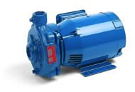
OVERHUNG IMPELLER, CLOSE COUPLED, SINGLE STAGE, END SUCTION  This is the typical industrial submersible or sump pump. They resemble a wet-pit volute pump except that the motor also is submerged. They are very popular for controlling water level in sumps in all types of industry. They are usually connected to a flexible hose and are appealing to users because they are easily removed for maintenance. Flygt is a major recognized supplier of these types of pumps.  For an example see  www.flygt.com | 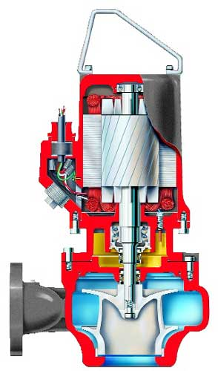
OVERHUNG IMPELLER, CLOSE COUPLED, SINGLE STAGE, END SUCTION  (CANNED MOTOR PUMP)  This a completely leakproof seal-less volute type pump and is intended for pumping corrosive, volatile, radioactive and otherwise difficult to handle or toxic fluids where even small quantities of leakage cannot be tolerated.  For an example see:  http://www.sundyne.com/index.cfm?lang=english | 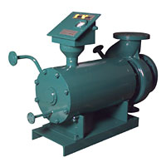
OVERHUNG IMPELLER, CLOSE COUPLED SINGLE STAGE, IN-LINE  A smaller version of the separately coupled in-line pump, used for the same purpose. Also used in commercial applications.  For an example see  http://www.aurorapump.com/products/326A.asp | 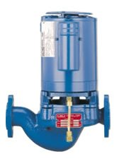
OVERHUNG IMPELLER, SEPARATELY COUPLED, SINGLE STAGE, IN-LINE  Often used in the petrochemical, chemical and refining industries. Mounts in and is supported by the piping system. Eliminates the foundation and grouting costs.  For an example see:  http://www.gouldspumps.com/  cat_pumps.ihtml?pid=233&lastcatid=88&step=4 | 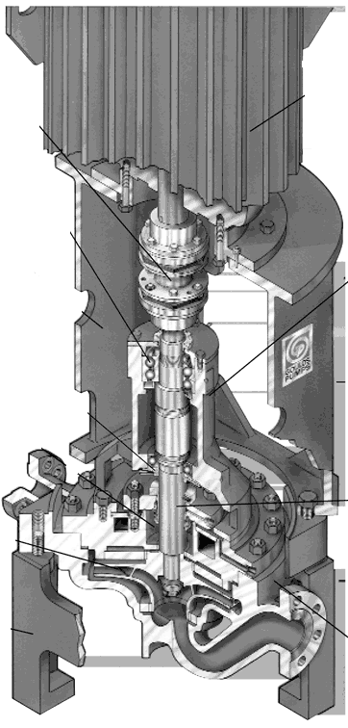
OVERHUNG IMPELLER, SEPARATELY COUPLED, SINGLE STAGE, CENTERLINE SUPPORT API 610  High temperature, high pressure process pump. The pump is supported on the centerline of its casing which provides for even thermal expansion on each side of the pump casing support. Can accommodate high temperature service without need of cooling water.  For an example see:  http://www.fpdlit.com/cms/results_detail.asp?ModelID=52 | 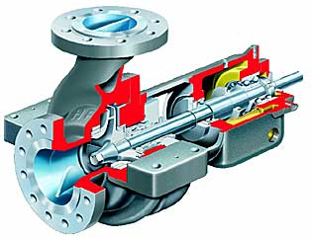
OVERHUNG IMPELLER, SEPARATELY COUPLED, FRAME MOUNTED  General service including industrial, chemical and commercial.  For an example see:  http://www.carverpump.com/products.asp | 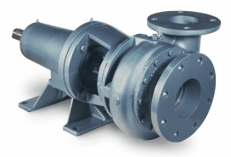
OVERHUNG IMPELLER, SEPARATELY COUPLED, SINGLE STAGE, WET PIT VOLUTE  This pump is designed to be suspended from an upper floor by means of a drop pipe and for pumping sewage or other solids laden liquids. This is also called a cantilever-shaft pump and has the feature that there are no seals or bearings below the liquid level.  For an example see:  http://www.haywardgordon.com/prorange/PUMPS/vertcant.htm | 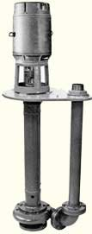
OVERHUNG IMPELLER, SEPARATELY COUPLED, SINGLE STAGE, FRAME MOUNTED ANSI B73.1  Chemical process pump, general industrial service. Back pull-out design, maximum interchangeability of parts. Adherence to the ANSI B73.1 code provides for maximum interchangeability of pars.  For an example see:  http://www.fpdlit.com/cms/results_detail.asp?ModelID=148 | 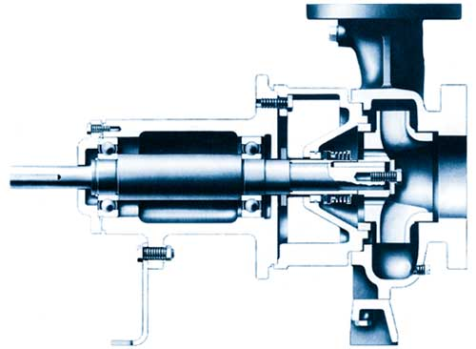
OVERHUNG IMPELLER, SEPARATELY COUPLED, SINGLE STAGE, AXIAL FLOW IMPELLER  High flow low head applications. Used in the chemical, mining, petroleum, pulp & paper, food, municipal and general applications.  For an example see:  http://www.gouldspumps.com/  cat_pumps.ihtml?pid=236&lastcatid=80&step=4 | 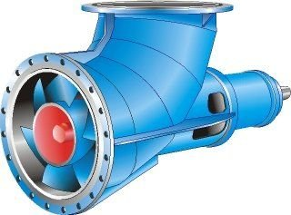
IMPELLER BETWEEN BEARINGS, SEPARATELY COUPLED, SINGLE STAGE, AXIAL HORIZONTAL SPLIT CASE  Also known as a double suction pump. Design permits removal of upper half for inspection, maintenance without disturbing piping or motor. Radially and axially balanced for long life. Wide variety of applications including: process, pulp & paper, primary metals, municipal, power generation, marine and general. | 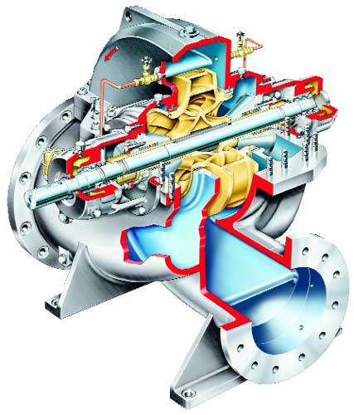
IMPELLER BETWEEN BEARINGS, SEPARATELY COUPLED, SINGLE STAGE, RADIAL VERTICAL SPLIT CASE | 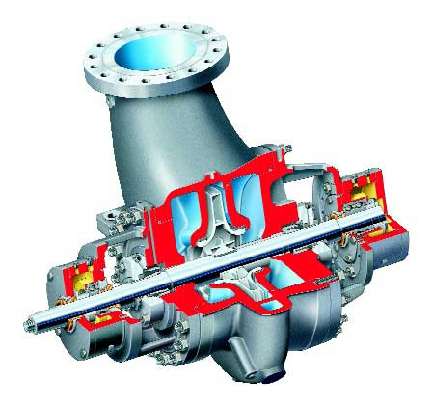
IMPELLER BETWEEN BEARINGS, SEPARATELY COUPLED, MULTISTAGE, AXIAL HORIZONTAL SPLIT CASE  Design permits removal of upper half for inspection, maintenance without disturbing piping or motor. Radially and axially balanced for long life. Used in boiler feed, mine dewatering, booster, high pressure process, condensate and high pressure cleaning applications. | 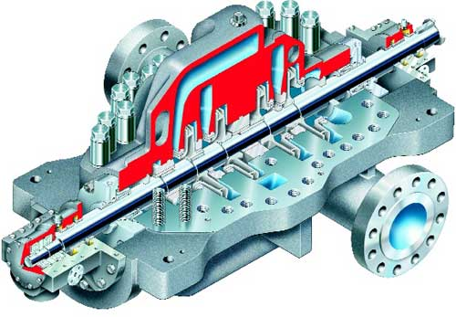
IMPELLER BETWEEN BEARINGS, SEPARATELY COUPLED, MULTISTAGE, RADIAL VERTICALLY SPLIT CASE | 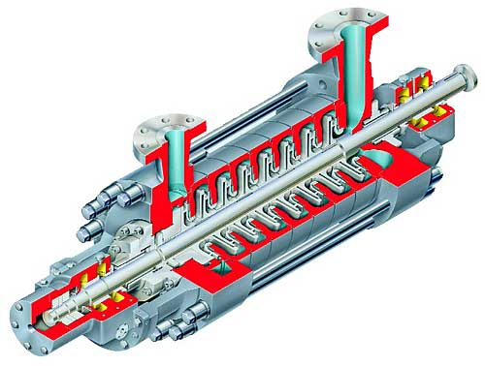
TURBINE, VERTICAL TYPE, MULTISTAGE, DEEP WELL  Large range of capacity and head. Used for cooling water, seawater and river intake, industrial process, utlity water circulation, condenser circulating and offshore. Designed for ease of maintenance. Stages can be easily added.  For an example see:  http://www.fpdlit.com/cms/results_detail.asp?ModelID=124 | 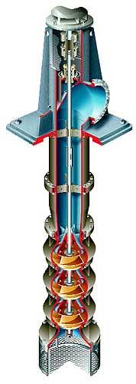
TURBINE, VERTICAL TYPE, MULTISTAGE, DEEP WELL, SUBMERSIBLE | 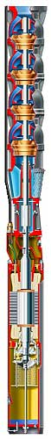
TURBINE, VERTICAL TYPE, MULTISTAGE, DEEP WELL, BARRELL OR CAN PUMP | 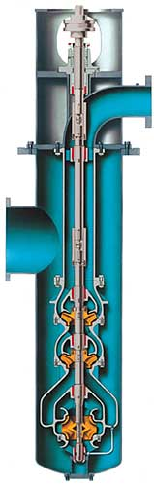
TURBINE, VERTICAL TYPE, MULTISTAGE, DEEP WELL AXIAL FLOW IMPELLER | 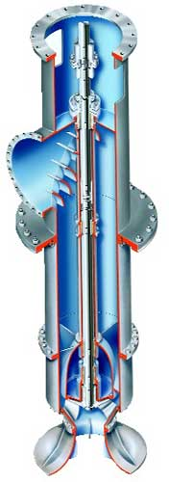
REGENERATIVE TURBINE, IMPELLER BETWEEN BEARINGS, SINGLE STAGE  Used for low flow high head applications such as boiler feed supply. This design is not susceptible to the same problems as a centrifugal pump when operating at low flow. Can handle up to 20% entrained air and can operate in the reverse direction thereby the term regenerative. see www.dynafloweng.com | 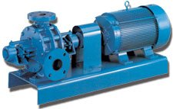
SPECIAL EFFECT, ROTATING CASING (PITOT)  Used for high pressure applications where conventional multistage pumps are not desirable, only two working parts. Used in boiler feed and desuperheating, central high pressure cleaning, oil production, mining, pulp & paper.  www.rotojet.com | 