TOTAL HEAD, N.P.S.H. AND OTHER CALCULATION EXAMPLES
Jacques Chaurette p. eng.,
www.lightmypump.com

June 2003

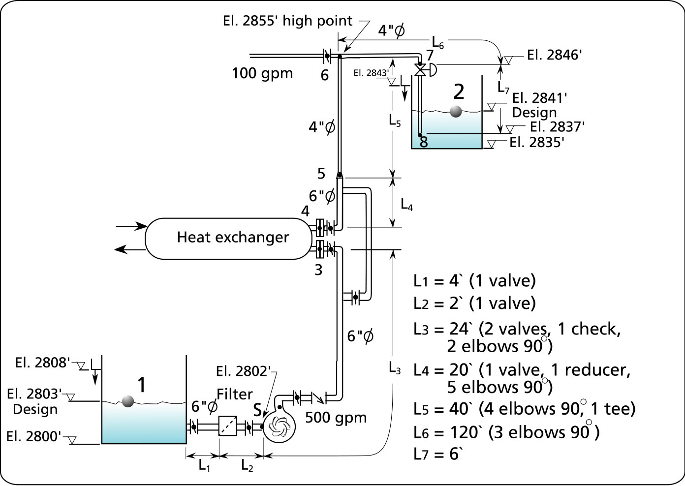
Figure 1 Calculation example flow schematic.

Situation

Water at 150 °F is to be pumped from a collecting tank located at the basement level (elevation 2800’ above sea level). Both the suction and discharge tanks have a square section (6’L x 6’W x 10’ H), the overflow level is at 8’ from the bottom of the tanks. The flow through the pump is 500 USgpm and it is located on the basement floor. There is a filter on the suction line and a heat exchanger on the discharge side of the pump. The manufacturer of the filter specifies that there will be a pressure drop of 3 psi at 500 gpm. The manufacturer of the heat exchanger specifies that there will be a pressure drop of 5 psi at 500 gpm. There is a branch on the discharge side of the pump that requires 100 gpm. The control valve pressure head drop will be 10 feet of fluid. The piping material is stainless steel ID piping. All the manual valves are fully open butterfly valves.

Notes and instructions: disregard the reducer loss in the calculation. This calculation can be done however it is long it does not significantly enhance this exercise. For the pressure head loss due to the check valve use the CV coefficient given in Figure 5 and not the Hydraulic Institute fittings pressure head loss chart in Figure 9. The total head of the pump depends on the path of fluid particles that demands the most energy. It has been established that this path is between points 1 and 2 (see Figure 1). To calculate the friction loss in the pipe you may use schedule 40 new steel pipe friction table by Cameron included in this example or you can calculate the loss using the Darcy-Weisbach equation with the Moody diagram or the Colebrook or Swamee-Jain equation.

Your task is to:

- Calculate the total head and select the pump.
- Calculate the NPSH available and check with respect to the NPSH required.
- Calculate the specific speed and predict the pump efficiency. Calculate the suction specific speed and Thoma number and check the prediction of the Thoma number regarding cavitation.
- Calculate the temperature rise of the fluid within the pump and compare with the maximum recommended.
- Calculate the pressure ahead of the control valve using method 1 which uses the flow data between points 1 and the control valve inlet point 7 (see Figure 3) and method 2 which uses the flow data between points 2 and the control valve inlet point 7 (see Figure 3).

CALCULATIONS

1. Calculate the total head and select the pump

Total head is given by formula [1]. For the meaning of the variables see the nomenclature in table 20. If you would like to know more about how this equation was derived see J. Chaurette’s book “Pump System Analysis and Centrifugal Pump Sizing” available at http://www.lightmypump.com/pump_book.htm (reference 1).

$${ΔH}_{P}(\text{ft}\text{}\text{fluid})=({ΔH}_{F1−2}+{ΔH}_{\text{EQ}1−2})+\frac{1}{2g}(v_{2^{2}}−v_{1^{2}})+z_{2}+H_{2}−(z_{1}+H_{1})$$ | [1]

Pressure head loss due to pipe friction

The velocity in the pipe is given by formula [2].

$$v({\text{ft}}/s) = 0\text{.}\text{4085} × \frac{Q(\text{USgal}\text{.}\text{/min})}{D^{2} {(\text{in})}^{2}}$$ | [2]

The pressure head loss or piping friction is provided for in an extract of Cameron Hydraulic data book (see Figures 5 and 6). For the purpose of this exercise use schedule 40 steel pipe. The friction loss in pipes is typically given in terms of feet of fluid per 100 feet of pipe that the fluid moves through.

$$\frac{ΔH_{\text{FP}}}{L} \left(\frac{\text{ft} \text{fluid}}{\text{100} \text{ft} \text{pipe}}\right) = \text{see} \text{Cameron} \text{tables}$$

Or use the the Darcy-Weisbach equation with the Moody diagram (see Figure 15) or the Colebrook or Swamee-Jain equation.

Darcy-Weisbach equation
$$\frac{{ΔH}_{\text{FP}}}{L}\left(\frac{\text{ft} \text{fluid}}{\text{100}\text{ft} \text{of}\text{pipe}}\right) = \text{1200} f \frac{{(v({\text{ft}}/s))}^{2}}{D (\text{in}) × 2g ({\text{ft}}/{s^{2}})}$$

Colebrook equation
$$\frac{1}{\sqrt{f}}\text{=-}2{\text{log}}_{\text{10}}\left(\frac{e}{3\text{.}7D}+\frac{2\text{.}\text{51}}{R_{e}\sqrt{f}}\right)$$

Swamee-Jain equation
$$f=\frac{0\text{.}\text{25}}{{\left({\text{log}}_{\text{10}}\left(\frac{e}{3\text{.}7D}+\frac{5\text{.}\text{74}}{R_{e^{0\text{.}9}}}\right)\right)}^{2}}$$

SECTION | FLOW (Usgal/min) | DIA  (in) | VELOCITY (ft/s) | ΔH_{FP}/L  (ft/100 ft pipe) | L  (ft) | ΔH_{FP}  (ft fluid)
L₁ | 500 | 6 | 5.67 | 1.64 | 4 | 0.06
L₂ | 500 | 6 | 5.67 | 1.64 | 2 | 0.03
L₃ | 500 | 6 | 5.67 | 1.64 | 24 | 0.39
L₄ | 500 | 6 | 5.67 | 1.64 | 20 | 0.32
L₅ | 500 | 4 | 12.76 | 13.1 | 40 | 5.2
L₆ | 400 | 4 | 10.21 | 8.51 | 120 | 10.2
Sub-total  ΔH_{FP1-7} | - | - | - | - | - | 16.2
L₇ | 400 | 4 | 10.21 | 8.51 | 6 | 0.51
Total  ΔH_{FP1-2} | - | - | - | - | - | 16.71
Table 1 Friction loss for all pipe segments.

Sample calculation for line segment L₁

The friction loss in feet of fluid for 100 feet of pipe from the table in Figure 6 is 1.64. The friction loss is then:

$${ΔH}_{\text{FP}} (\text{ft} \text{fluid}) = 1\text{.}\text{64} × \frac{4}{\text{100}} = 0\text{.}\text{06}$$

Pressure head loss due to fittings friction

The friction loss for fittings is given by formula [3].

$$ΔH_{\text{FF}} (\text{ft} \text{fluid}) = K\frac{v^{2}{({\text{ft}}/s)}^{2}}{2g({\text{ft}}/{s^{2}})} \text{for} K \text{see} \text{table}$$ | [3]

The K factors for the different fittings type is given in the form of graphs (see Figures 8 and 9 which are extracts of the Hydraulic Engineering’s Standards book, www.pumps.org). Use these figures for the K factors in equation [3] for fittings and manual valves.

SECTION | FLOW (Usgal/min) | TYPE | QTY | DIA  (in) | VELOCITY  (ft/s) | v²/2g  (ft fluid) | K | ΔH_{FF}  (ft fluid)
L₁ | 500 | Entrance | 1 | 6 | 5.67 | 0.5 | 1 | 0.5
L₁ | 500 | Butterfly | 1 | 6 | 5.67 | 0.5 | 1 | 0.5
L₂ | 500 | Butterfly | 1 | 6 | 5.67 | 0.5 | 1 | 0.5
L₃ | 500 | Butterfly | 2 | 6 | 5.67 | 0.5 | 1 | 1
L₃ | 500 | Elbows | 2 | 6 | 5.67 | 0.5 | 0.28 | 0.28
L₄ | 500 | Elbows | 5 | 6 | 5.67 | 0.5 | 0.28 | 0.7
L₄ | 500 | Butterfly | 1 | 6 | 5.67 | 0.5 | 1 | 0.5
L₅ | 500 | Elbows | 4 | 4 | 12.76 | 2.53 | 0.32 | 3.2
L₅ | 500 | Tee | 1 | 4 | 12.76 | 2.53 | 0.7 | 1.77
L₆ | 400 | Elbows | 3 | 4 | 10.21 | 1.62 | 0.32 | 1.55
Sub-total  ΔH_{FF1-7} | - | - | - | - | - | - | - | 10.5
L₇ | 400 | Pipe exit | 1 | 4 | 10.21 | 1.62 | 1 | 1.62
Total  ΔH_{FF1-2} | - | - | - | - | - | - | - | 12.12
Table 2. Friction loss for fittings.

Sample calculation for line segment L₁

The K value for the entrance loss is 1. The friction loss is then:

$$ΔH_{\text{FF}} (\text{ft} \text{fluid}) = 1 × \frac{{5\text{.}\text{67}}^{2}{({\text{ft}}/s)}^{2}}{2 × \text{32}\text{.}\text{17}({\text{ft}}/{s^{2}})} = 0\text{.}5$$

Pressure head loss due to equipment

$$H ( \text{ft} \text{fluid} ) = 2\text{.}\text{31}\frac{p(\text{psi})}{\text{SG}}$$ | [4]

The pressure drop across the filter is given by the manufacturer, 3 psi at 500 gpm. We can calculate the pressure head loss by using equation [4]. The value of the specific gravity SG is very close to one, for water this value changes with the temperature (see Figure 12). A similar approach is taken for the heat exchanger whose pressure drop is given as 5 psi.

The control valve is a different matter, if this is a new system we will have to assume a reasonable value for a pressure drop that is consistent with good practice. Consultants have found that in general if one assumes a pressure head drop of 10 ft of fluid it will always be possible to select a valve of a reasonable size that will provide good control. If the system is existing then the manufacturer’s data will have to be used to calculate the pressure drop for that specific valve at 500 gpm.

SECTION | FLOW (Usgal/min) | TYPE | QTY | Δp  (psi) | SG | Δp  (ft fluid) | ΔH_{EQ}  (ft fluid)
L₂ | 500 | Filter | 1 | 3 | 0.98 | 7.07 | 7.07
L₃ | 500 | Heat exchanger | 1 | 5 | 0.98 | 11.78 | 11.78
L₇ | 400 | Control valve | 1 | 4.24 | 0.98 | 10 | 10
Total  ΔH_{EQ1-2} | - | - | - | - | - | - | 28.86
Table 3. Friction loss of the equipment.
Note: Δp control valve = 10 ft fluid

Pressure head loss due to the check valve

To calculate the pressure head drop across the check valve we use the CV of the valve. The valve flow coefficient (CV) is used as an indicator of the pressure drop across a valve under specific flow conditions and is formally defined as the number of gallons per minute of room temperature water that will flow through the valve with a pressure drop of 1 psi across the valve (see equation [5]). The value for the check valve CV can be found in the table of Figure 4.

$$\text{CV} = \frac{q(\text{USgpm})}{\sqrt{\frac{Δp(\text{psi})}{\text{SG}}}}$$ | [5]
We can obtain the value of the pressure drop (Δp) across the check valve by using equation [6] which is equation [5] with the pressure drop term isolated on the left hand side of the equation.

$$Δp(\text{psi})={\left(\frac{q(\text{gpm})}{\text{CV}\left(\frac{\text{gpm}}{{\text{psi}}^{1/2}}\right)}\right)}^{2} × \text{SG}$$ | [6]
TYPE | FLOW (Usgal/min) | QTY | DIA (in) | SG | CV (gpm/psi^{1/2} ) | Δp  (psi) | ΔH_{check}(ft fluid)
Tilting disc | 500 | 1 | 6 | .98 | 590 | 0.7 | 1.65
Table 4

Total static head

Total static head is the difference between the elevations of the liquid surface of the discharge tank vs. the suction tank.

z₁ | z₂ | z₂-z₁ (ft fluid)
2803 | 2841 | 38

Velocity head difference between the outlet and inlet of the system

v₁ and v₂ are respectively the velocities of the fluid particles at the inlet of the system and the outlet. The inlet of the system is at the position of the surface of the liquid in the suction tank. The velocity (v₁) of the fluid particles at the surface is quite low and small enough to be considered nil. The outlet of the system is at the position of the surface of the liquid in the discharge tank. The velocity (v₂) of the fluid particles at the surface is quite low and small enough to be considered nil.
Notice that the discharge end of the pipe is submerged, the fluid particles will travel from the discharge pipe end to the liquid surface in the discharge tank. If the pipe were not submerged then the outlet of the system would be located at the discharge pipe end and the velocity v₂ would be the velocity at the end of the pipe.

v₁ | v₂ | v₁²/2g | v²₂/2g | v²₂/2g – v₁²/2g (ft fluid)
0 | 0 | 0 | 0 | 0

Tank pressure head difference between the outlet and inlet of the system

If the suction tank were pressurized with pressure p₁, there would be a corresponding pressure head H₁. Since the tank is not pressurized and is open to atmosphere then the pressure p₁ is zero and therefore H₁ is zero. The same applies to the discharge tank.

H₁ | H₂ | H₂ – H₁ (ft fluid)
0 | 0 | 0

Calculation results (total head)

Table 5 brings together all the previous calculations and the result is the total head required of the pump.

Component | Sign | (ft fluid) | Results
Pipe friction head loss | + | ΔH_{FP1-2} | 16.71
Fittings friction head loss | + | ΔH_{FF1-2} | 12.12
Equipment friction head loss | + | ΔH_{EQ1-2} | 28.86
Check valve head loss | + | ΔH_{CHECK} | 1.65
Total static head | + | z₂ – z₁ | 38
Velocity head difference | + | v²₂/2g – v₁²/2g | 0
Tank pressure head difference | + | H₁ – H₂ | 0
Total head (ft fluid) | = | ΔH_{P} | 97.34
Table 5. Summary of the calculation results of the total head.

Brake horsepower
(determine the pump efficiency from the pump performance curve prior to doing this calculation)

The power absorbed by the pump is given by equation[7] (see reference 1):

$$P_{\text{pump}}(\text{hp}) = \frac{\text{SG} × \text{}{ΔH}_{P}(\text{ft} \text{fluid}) × \text{} q(\text{US}\text{gal}\text{/min})}{\text{3960} × η_{\text{pump}}}$$ | [7]

For example, we have selected an impeller size of 10.7 inches (see Figure 12). The pump efficiency at 500 gpm is given by the pump’s characteristic curve and is 0.71. The total head is 97.3 feet as calculated.

$$P_{\text{pump}}(\text{hp}) = \frac{0\text{.}\text{98} × \text{97}\text{.}3 × \text{500}}{\text{3960} × 0\text{.}\text{71}} = \text{16}\text{.}9$$

SPECIFIC GRAVITY  SG | TOTAL HEAD  ΔH_{P} (ft fluid) | FLOW  q (Usgal/min) | PUMP EFFICIENCY  η | BRAKE HORSEPOWER  P(hp)
0.98 | 97.3 | 500 | .713 | 16.9
Table 6 Power to the pump shaft calculation results.

PUMP SELECTION DATA

This table lists the important information on the pump that was selected to meet the process requirements.

Pump Manufacturer | Goulds
Pump Model | 3175 3X6-12
Type | End suction, direct drive
Suction dia. (in) | 6
Discharge dia. (in) | 3
Impeller speed (rpm) | 1750
Operating head (ft) | 97.3
Operating Flow (Usgpm) | 500
Pump efficiency (%) | 71.3
Predicted efficiency (%) | 77
Specific speed
Suction specific speed
Temperature rise (°F)
Fluid type | Water
Viscosity (cSt) | 1.1
Temperature (°F) | 150
Specific gravity | 0.98
Specific heat (Btu/lb-°F) | 1.0
Brake horsepower (hp) | 16.9
Selected horsepower (hp) | 20
Frame | 256 T
Pump shut-off head (ft) | 122
System high point (ft) z_{high} – z₁ | 52
NPSH required (ft abs.) | 6
NPSH available (ft abs.) | 15.3
Max. impeller size (in) | 12
Min. impeller size (in) | 9
Selected impeller size (in) | 10.7
Table 7 Summary of the pump data.

2. Calculate the N.P.S.H. available and check against the N.P.S.H. required.

Most of the data required for the N.P.S.H. available has already been calculated.

H_{S} (see equation [8a]) is the pressure head at point S or the pump suction. The N.P.S.H. available is the value of the pressure head available at point S (H_{S}) plus the atmospheric pressure minus the vapor pressure of the liquid.

$$N\text{.}P\text{.}S\text{.}H{\text{.}}_{\text{avail}\text{.}} ( \text{ft} \text{fluid} \text{abs}\text{.} ) = H_{S} + H_{A} − H_{\text{va}}$$ | [8a]

The value of the pressure head (H_{S}) at point S (see equation [8b]) will depend on the pipe and equipment loss between points 1 and S plus the velocity head at point 1 and plus the elevation difference the two same points. If you would like to know more about how this equation was derived see reference 1.

$$H_{S} = −({ΔH}_{F1−S}+{ΔH}_{\text{EQ}1−S}) + \frac{v_{1^{2}}}{2g} + (z_{1}−z_{S}+H_{1})$$ | [8b]

By replacing the value of H_{S} in equation [8b] into equation [8a] we obtain the N.P.S.H. available (see equation [8c]).

$$N\text{.}P\text{.}S\text{.}H{\text{.}}_{\text{avail}\text{.}} ( \text{ft} \text{fluid} \text{abs}\text{.} ) = −({ΔH}_{F1−S}+{ΔH}_{\text{EQ}1−S}) + \frac{v_{1^{2}}}{2g} + (z_{1}−z_{S}+H_{1}) + H_{A} −H_{\text{va}}$$ | [8c]

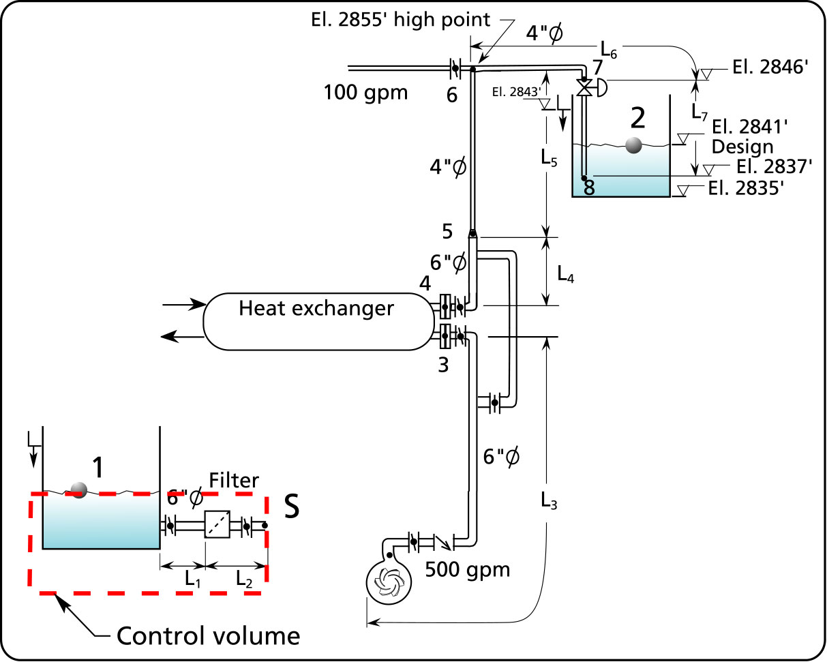
Figure 2 Position of the control volume which allows the calculation of the pressure head at point S.

Pressure head loss due to pipe friction

SECTION | FLOW (Usgal/min) | DIA  (in) | VELOCITY  (ft/s) | ΔH_{FP}/L  (ft/100 ft pipe) | L  (ft) | ΔH_{FP}  (ft fluid)
L₁ | 500 | 6 | 5.67 | 1.64 | 4 | 0.06
L₂ | 500 | 6 | 5.67 | 1.64 | 2 | 0.03
Total  ΔH_{FP1-S} | - | - | - | - | - | 0.09
Table 8

Pressure head loss due to fittings friction

SECTION | TYPE | QTY | FLOW (USgal/min) | DIA  (in) | VELOCITY (ft/s) | v²/2g  (ft fluid) | K | ΔH_{FF}  (ft fluid)
L₁ | Inward proj. entrance | 1 | 500 | 6 | 5.67 | 0.5 | 1 | 0.5
L₁ | Butterfly | 1 | 500 | 6 | 5.67 | 0.5 | 1 | 0.5
L₂ | Butterfly | 1 | 500 | 6 | 5.67 | 0.5 | 1 | 0.5
Total  ΔH_{FF1-S} | - | - | - | - | - | - | - | 1.5
Table 9

Pressure head loss due to equipment

SECTION | TYPE | QTY | FLOW (USgal/min) | Δp  (psi) | SG | Δp  (ft fluid) | ΔH_{EQ1-S}  (ft fluid)
L₂ | Filter | 1 | 500 | 3 | 0.98 | 7.07 | 7.07
Table 10

Suction static head

z₁ | z_{S} | z₁-z_{S} (ft fluid)
2803 | 2802 | 1

Tank pressure head at the inlet of the system

H₁ (ft fluid)
0

Velocity head at the inlet of the system

v₁ | v²₁/2g (ft fluid)
0 | 0

Atmospheric pressure head

The atmospheric pressure in the environment of the pump depends on the elevation above sea level or the plant ground floor elevation which is considered precise enough. The chart in Figure 11 gives the pressure in psia corresponding to the pump’s elevation. Using equation [4] we can calculate the corresponding pressure head.

p_{A}(psia) | SG | H_{A}(ft fluid abs.)
13.3 | 0.98 | 31.35

Vapor pressure head

The vapor pressure of the fluid depends on it’s temperature. The table in Figure 11 gives the vapor pressure in psia corresponding to the temperature. Using equation [4] we can calculate the corresponding pressure head.

p_{va}(psia) | SG | H_{va}(ft fluid abs.)
3.6 | 0.98 | 8.47

Calculation results (N.P.S.H. available)

Component | Sign | (ft fluid) | Results
Pipe friction head loss | - | ΔH_{FP1-S} | 0.09
Fittings friction head loss | - | ΔH_{FF1-S} | 1.5
Equipment friction head loss | - | ΔH_{EQ1-S} | 7.07
Suction static head | + | z₁ -z_{S} | 1
Tank pressure head | + | H₁ | 0
Velocity head | + | v₁²/2g | 0
Atmospheric pressure head | + | H_{B} | 31.35
Vapor pressure head | - | H_{va} | 8.47
NPSH _{avail.} (ft fluid abs.) | = | NPSH | 15.4
Table 11. Summary of the calculation results of the N.P.S.H. available.

Compare the calculated value of the N.P.S.H. available with the N.P.S.H. required that the pump manufacturer provides on the characteristic curve which is approximately 6 feet of water absolute. We have a comfortable margin of safety compared to our calculated value for the system.

3. Calculate the specific speed, suction specific speed and Thoma number and check the prediction of the Thoma number regarding cavitation

Specific speed (N_{S})

Specific speed is a number that provides an indication of the speed of the impeller, the flow rate and the head produced. The number is low, below 2000 (see Figure 13) for pumps of radial design that provide high head and low flow. It is large, over 10000, for pumps that provide high flow and low head. Along with the suction specific speed, it can be used to predict cavitation.
 | $$N_{S} = \frac{N(\text{rpm}) × \sqrt{Q(\text{USgpm})}}{H(\text{ft} \text{fluid})^{0\text{.}\text{75}}}$$ | [9]

 | $$N_{S} = \frac{\text{1780} × \sqrt{\text{500}}}{{\text{97}}^{0\text{.}\text{75}}} = \text{1287}$$ | [9a]
Predict the pump efficiency

The pump’s efficiency is directly related to its specific speed. Efficiency increases as specific speed increases. Also, as shown in Figure 14, the efficiency increases as flow rate increase, this means that larger pumps at the same specific speed are more efficient. . For impeller sizes larger than 10” the effect of size or increased flow rate is small and generally insignificant. For impeller sizes 4” and less , the penalty for smaller sizes is severe.

The efficiency predicted by the chart in is Figure 14 is 0.77.

Suction specific speed (S)

Suction specific speed is a number that is dimensionally similar to the pump specific speed and is used as a guide to prevent cavitation.

 | $$S = \frac{N(\text{rpm}) × \sqrt{Q(\text{USgpm})}}{N\text{.}P\text{.}S\text{.}H{\text{.}}_{A}(\text{ft} \text{fluid})^{0\text{.}\text{75}}}$$ | [10]

Instead of using the total head of the pump H, the N.P.S.H._{A} (Net Positive Suction Head available) is used. Also if the pump is a double suction pump then the flow value to be used is one half the total pump output.

The Hydraulic Institute recommends that the suction specific speed be limited to 8500. Some pump manufactures limit this value to 10,000-12,000.

 | $$S = \frac{\text{1780} × \sqrt{\text{500}}}{\text{15}\text{.}4^{0\text{.}\text{75}}} = \text{5120}$$ | [10a]

Thoma cavitation parameter σ

 | $$σ = \frac{N\text{.}P\text{.}S\text{.}H\text{.}}{H}$$ | [11]

The Thoma cavitation parameter is non dimensional and has been used to predict the onset of cavitation (see Figure 16). Use this number to verify that this pump will have sufficient N.P.S.H.A. to operate properly.

 | $$σ = \frac{N\text{.}P\text{.}S\text{.}H\text{.}A\text{.}}{H} = \frac{\text{15}\text{.}4}{\text{97}} = 0\text{.}\text{16}$$ | [11a]

4. Calculate the temperature rise of the fluid within the pump and compare with the maximum recommended

Because the transmission of power between the impeller and the fluid is inefficient, heat is generated, when the process is very inefficient such as at low flows allot of heat is generated. The pump manufacturer’s limit the amount of temperature rise to 15 °F. The temperature rise will depend on the total head, the specific heat of the fluid (water is 1 BTU/lb-°F) and the efficiency at the operating point.

To calculate the temperature rise:

 | $$ΔT(F) = \frac{H(\text{ft})}{\text{778} × \text{Cp}({\text{BTU}}/{\text{lb}}−F) × η}$$ | [12]

 | $$ΔT(F) = \frac{\text{97}}{\text{778} × 1 × \text{.}\text{713}}= 0\text{.}\text{17}$$ | [12a]

5. Calculate the pressure ahead of the control valve using method 1

It is important to know the pressure just at the inlet of a control valve. This information is required to size the valve and ensure that it will control properly and avoid cavitation.

Method 1

Method 1 consists of calculating the pressure at the inlet of the control valve by making use of the total head of the pump and the friction loss and elevation difference between the inlet of the system and point 7, the inlet of the valve.

H_{X} (see equation [13]) is the pressure head of any point we choose on the discharge side of the pump (see reference 1).

$$H_{X}={DH}_{P}−({DH}_{F1−X}+{DH}_{\text{EQ}1−X})+\frac{1}{2g}(v_{1^{2}}−v_{X^{2}})+(z_{1}+H_{1}−z_{X})$$ | [13]

In our case point X will be point 7 or the point just at the inlet of the control valve.
$$H_{7}={ΔH}_{P}−({ΔH}_{F1−7}+{ΔH}_{\text{EQ}1−7})+\frac{1}{2g}(v_{1^{2}}−v_{7^{2}})+(z_{1}+H_{1}−z_{7})$$ | [14]

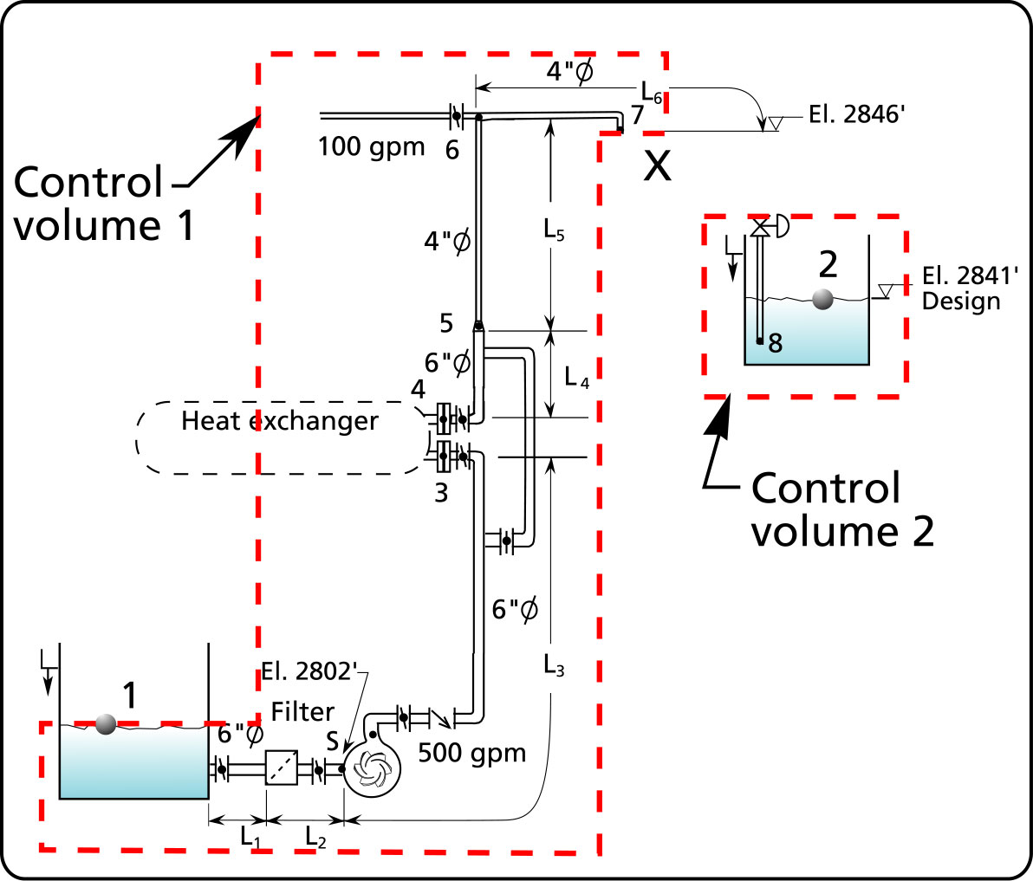
Figure 3 Position of point 7, the inlet of the control valve.

The value of the pressure head at point 7 depends on the total head of the pump minus the pipe and equipment head loss between points 1 and 7 minus the difference in velocity head between points 1 and 7 and minus the elevation difference between the two same points.

Once again most of the data required to calculate the pressure at point 7 has already been calculated.

Pressure head loss due to pipe friction

SECTION | FLOW (USgal/min) | DIA  (in) | VELOCITY (ft/s) | ΔH_{FP}/L  (ft/100 ft pipe) | L  (ft) | ΔH_{FP}  (ft fluid)
L₁ | 500 | 6 | 5.67 | 1.64 | 4 | 0.06
L₂ | 500 | 6 | 5.67 | 1.64 | 2 | 0.03
L₃ | 500 | 6 | 5.67 | 1.64 | 24 | 0.39
L₄ | 500 | 6 | 5.67 | 1.64 | 20 | 0.32
L₅ | 500 | 4 | 12.76 | 13.1 | 40 | 5.2
L₆ | 400 | 4 | 10.21 | 8.51 | 120 | 10.2
Total  ΔH_{FP1-7} | - | - | - | - | - | 16.2
Table 12

Pressure head loss due to fittings friction

SECTION | FLOW (USgal/min) | TYPE | QTY | DIA  (in) | VELOCITY (ft/s) | v²/2g  (ft fluid) | K | ΔH_{FF}  (ft fluid)
L₁ | 500 | Entrance | 1 | 6 | 5.67 | 0.5 | 1 | 0.5
L₁ | 500 | Butterfly | 1 | 6 | 5.67 | 0.5 | 1 | 0.5
L₂ | 500 | Butterfly | 1 | 6 | 5.67 | 0.5 | 1 | 0.5
L₃ | 500 | Butterfly | 2 | 6 | 5.67 | 0.5 | 1 | 1
L₃ | 500 | Elbows | 2 | 6 | 5.67 | 0.5 | 0.28 | 0.28
L₄ | 500 | Elbows | 5 | 6 | 5.67 | 0.5 | 0.28 | 0.7
L₄ | 500 | Butterfly | 1 | 6 | 5.67 | 0.5 | 1 | 0.5
L₅ | 500 | Elbows | 4 | 4 | 12.76 | 2.53 | 0.32 | 3.2
L₅ | 500 | Tee | 1 | 4 | 12.76 | 2.53 | 0.7 | 1.77
L₆ | 400 | Elbows | 3 | 4 | 10.21 | 1.62 | 0.32 | 1.55
Total  ΔH_{FF1-7} | - | - | - | - | - | - | - | 10.5
Table 13

Pressure head loss due to equipment

$$H ( \text{ft} \text{fluid} ) = 2\text{.}\text{31}\frac{p(\text{psi})}{\text{SG}}$$

SECTION | FLOW (USgal/min) | TYPE | QTY | Δp  (psi) | SG | Δp  (ft fluid) | ΔH_{EQ}  (ft fluid)
L₂ | 500 | Filter | 1 | 3 | 0.98 | 7.07 | 7.07
L₃ | 500 | Heat exchanger | 1 | 5 | 0.98 | 11.78 | 11.78
Total  ΔH_{EQ1-7} | - | - | - | - | - | - | 18.85
Table 14

Pressure head loss due to the check valve

$$Δp(\text{psi})={\left(\frac{q(\text{gpm})}{\text{CV}\left(\frac{\text{gpm}}{{\text{psi}}^{1/2}}\right)}\right)}^{2} × \text{SG}$$

TYPE | FLOW (USgal/min) | QTY | DIA (in) | CV(gpm/psi^{1/2} ) | SG | Δp  (psi) | ΔH_{check}  (ft fluid)
Tilting disc | 500 | 1 | 6 | 590 | 0.98 | 0.7 | 1.65
Table 15

Static head

z₁ | z₇ | z₁ – z₇ (ft fluid)
2803 | 2846 | - 43

Velocity head difference between points 1 and 7

v₁ | v₇ | v₁²/2g | v²₇/2g | v²₁/2g – v₇²/2g (ft fluid)
0 | 10.21 | 0 | 1.62 | - 1.62

Tank pressure head at the inlet of the system

H₁ (ft fluid)
0

Calculation results (method 1 – pressure at the control valve inlet)

The sign in the second column follows the signs of the terms in equation [16].

Component | Sign | (ft fluid) | Results
Total head | + | ΔH_{P} | 97.34
Pipe friction head loss | - | ΔH_{FP1-7} | 16.2
Fittings friction head loss | - | ΔH_{FF1-7} | 10.5
Equipment friction head loss | - | ΔH_{EQ1-7} | 18.85
Check valve head loss | - | ΔH_{CHECK} | 1.65
Total static head | + | z₁ – z₇ | - 43
Velocity head difference | + | v²₁/2g – v₇²/2g | - 1.62
Tank pressure head | + | H₁ | 0
Pressure head at the control valve (ft fluid) | = | H₇ | 5.52
Pressure at the control valve (psig) | = | p₇ | 2.34
Table 16 Summary of the results of the pressure calculation at point 7.

5. Calculate the pressure ahead of the control valve using method 2

Method 2

Method 2 consists of calculating the pressure at the inlet of the control valve by making use of the friction loss and elevation difference between the outlet of the system and point 7, the inlet of the valve.

H_{X} (equation [17] is the pressure of any point we choose on the discharge side of the pump.

$$H_{X}={ΔH}_{\text{FX}−2}+{ΔH}_{\text{EQX}−2}+\frac{1}{2g}(v_{2^{2}}−v_{X^{2}})+(z_{2}+H_{2}−z_{X})$$ | [17]

In our case point X will be point 7 or the point just at the inlet of the control valve.
$$H_{7}={ΔH}_{F7−2}+{ΔH}_{\text{EQ}7−2}+\frac{1}{2g}(v_{2^{2}}−v_{7^{2}})+(z_{2}+H_{2}−z_{7})$$ | [18]

The value of the pressure head at point 7 will depend on the pipe and equipment loss between points 7 and 2 (the outlet) plus the difference in velocity heads between points 2 and 7 and plus the elevation difference between the two same points. Notice that with this method we do not consider the total head of the pump.

The pressure at point 7 is dictated by the flow rate. The fluid particles that are ahead of point 7 do not know that they have gotten to that point thanks to the energy supplied by the pump, all that they see is that they have arrived at point 7 with a certain amount of pressure and velocity. We can therefore do an energy balance between points 7 and 2 and find out what the pressure at point 7 has to be to maintain the pressure and velocity energy at this point.

Pressure head loss due to pipe friction

SECTION | FLOW (USgal/min) | DIA  (in) | VELOCITY (ft/s) | ΔH_{FP}/L  (ft/100 ft pipe) | L  (ft) | ΔH_{FP7-2}  (ft fluid)
L₇ | 400 | 4 | 10.21 | 8.51 | 6 | 0.51
Total
ΔH_{FP7-2}
Table 17

Pressure head loss due to fittings friction

SECTION | FLOW (USgal/min) | TYPE | QTY | DIA  (in) | VELOCITY (ft/s) | v²/2g  (ft fluid) | K | ΔH_{FF7-2}  (ft fluid)
L₇ | 400 | Pipe exit | 1 | 4 | 10.21 | 1.62 | 1 | 1.62
Total
ΔH_{FF7-2}
Table 18

Pressure head loss due to equipment

$$H ( \text{ft} \text{fluid} ) = 2\text{.}\text{31}\frac{p(\text{psi})}{\text{SG}}$$

SECTION | FLOW (USgal/min) | TYPE | QTY | Δp  (psi) | SG | Δp  (ft fluid) | ΔH_{EQ7-2}  (ft fluid)
L₇ | 400 | Control valve | 1 | 4.24 | 0.98 | 10 | 10
Total
ΔH_{EQ7-2}
Table 19

Total static head

z₇ | z₂ | z₂-z₇ (ft fluid)
2846 | 2841 | - 5

Velocity head difference between points 7 and 2

v₇ | v₂ | v₇²/2g | v²₂/2g | v²₂/2g – v₇²/2g (ft fluid)
10.21 | 0 | 1.62 | 0 | - 1.62

Tank pressure head at the outlet of the system

H₂ (ft fluid)
0

Calculation results (method 2 – pressure at the control valve inlet)

The sign in the second column follows the signs of the terms in equation [18].
Component | Sign | (ft fluid) | Results
Pipe friction head loss | + | ΔH_{FP7-2} | 0.51
Fittings friction head loss | + | ΔH_{FF7-2} | 1.62
Equipment friction head loss | + | ΔH_{EQ7-2} | 10
Static head | + | z₂ – z₇ | - 5
Velocity head difference | + | v²₂/2g – v₇²/2g | - 1.62
Tank pressure head | + | H₂ | 0
Pressure head at the control valve (ft fluid) | = | H₇ | 5.51
Pressure at the control valve (psig) | = | p₇ | 2.34
Table 20 Results of the pressure calculation at point 7.

Symbols

Variable nomenclature | Imperial system  (FPS units) | Metric system  (SI units)
H head | ft (feet) | m (meter)
ΔH_{P} total tead | ft (feet) | m (meter)
ΔH_{EQ1-2} equipment friction head loss between points 1 and 2 | ft (feet) | m (meter)
ΔH_{F1-2} friction head loss in pipes between points 1 and 2 | ft (feet) | m (meter)
H_{A} atmospheric pressure head | ft (feet) | m (meter)
H_{va} vapor pressure head | ft (feet) | m (meter)
p pressure | psi (pound per square inch) | kPa (kiloPascal)
SG specific gravity; ratio of the fluid density to the density of water at standard conditions | non-dimensional
N_{S} Specific speed
S Suction specific speed
c_{p} Specific heat | BTU/lb-°F | KJ/kg-°C
σ Thoma cavitation parameter | non-dimensional
q flow rate | gpm (gals./min) | L/min (liters/mi)
v velocity | ft/s (feet/second) | m/s (meter/second)
g acceleration due to gravity, 32.17 ft/s² | ft/s² (feet/second squared) | m/s² (meter/second squared)
z vertical position | ft (feet) | m (meter)
Table 21 Variable nomenclature.

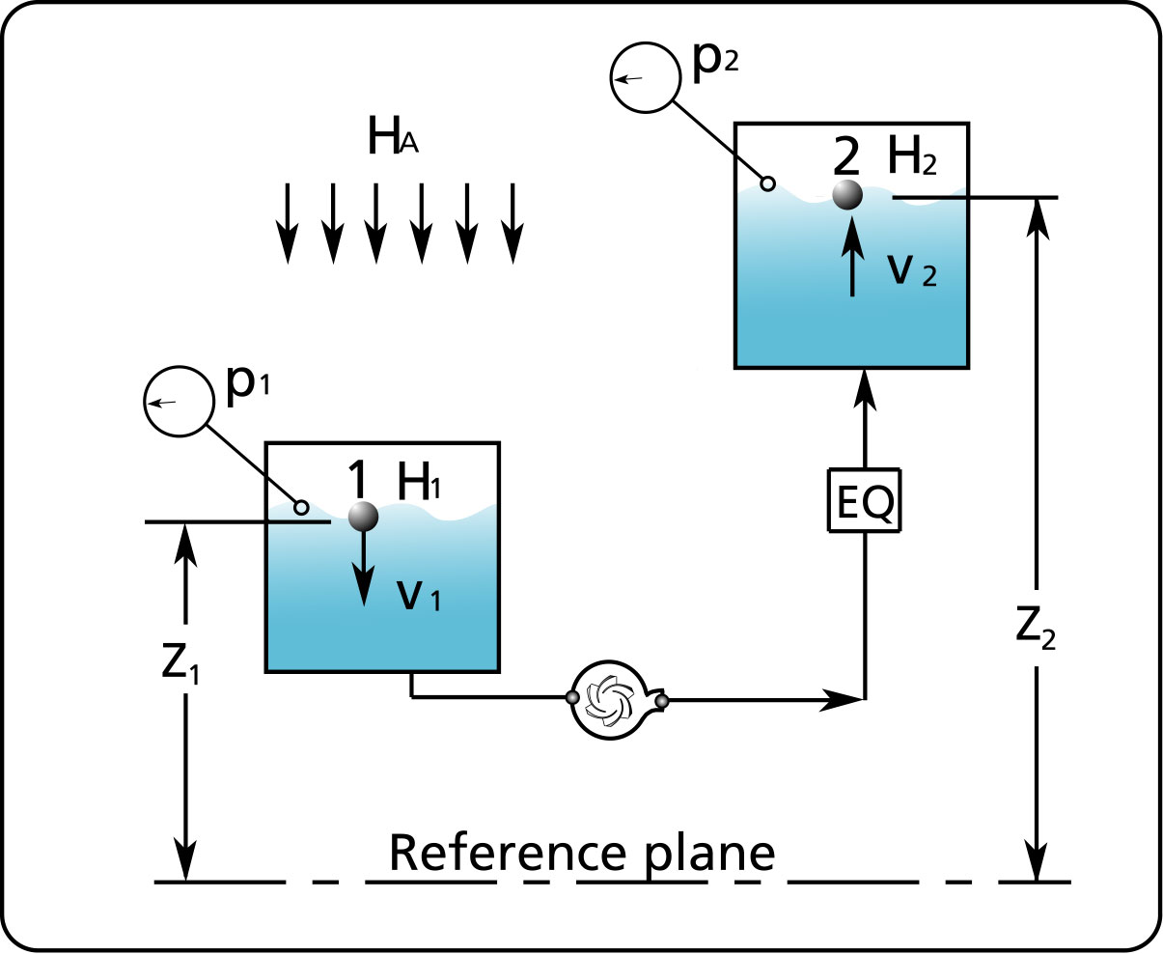
Figure 4 Nomenclature

References

- Pump System Analysis and Centrifugal Pump Sizing by J. Chaurette published by http://www.lightmypump.com/pump_book.htm, January2003

- Standards by the Hydraulic Institute, New Jersey www.pumps.org

- The Cameron Hydraulic data book by Ingersoll Rand

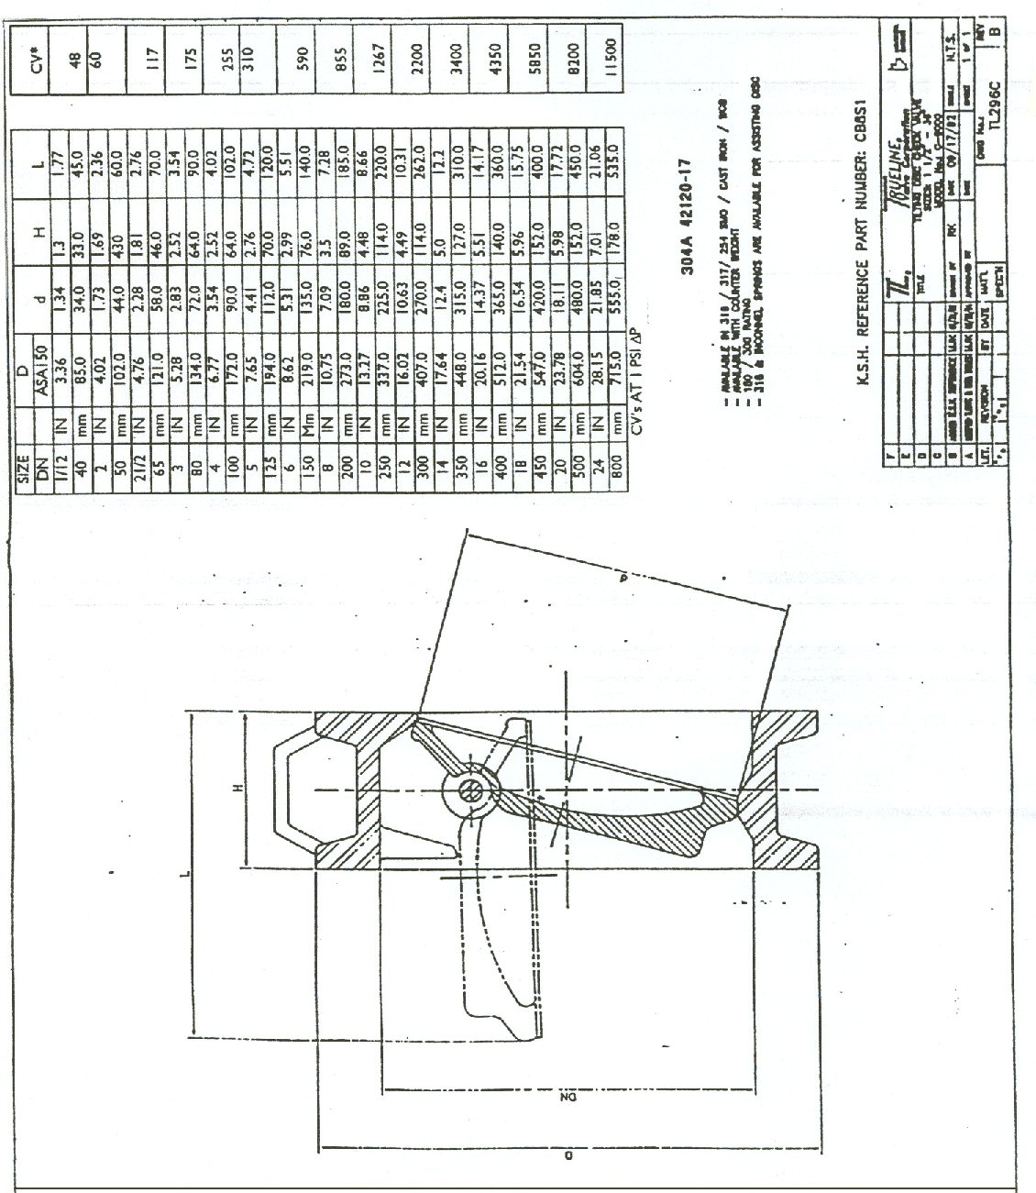
Figure 5 CV coefficients for check valves (source Trueline Valve Corp).

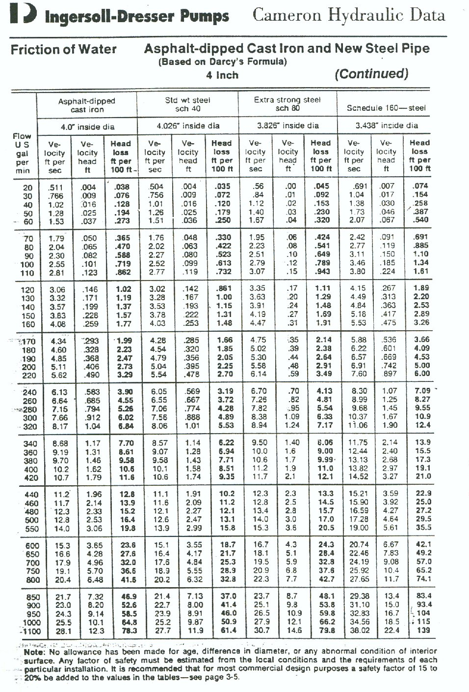
Figure 6 Piping pressure head losses (source Cameron Hydraulic data book).

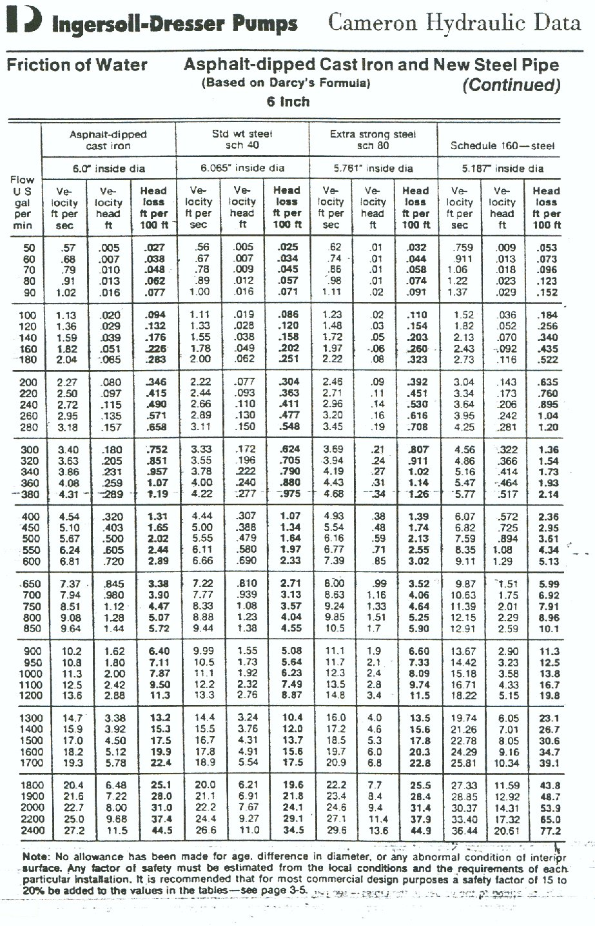
Figure 7 Piping pressure head losses (source Cameron Hydraulic data book).

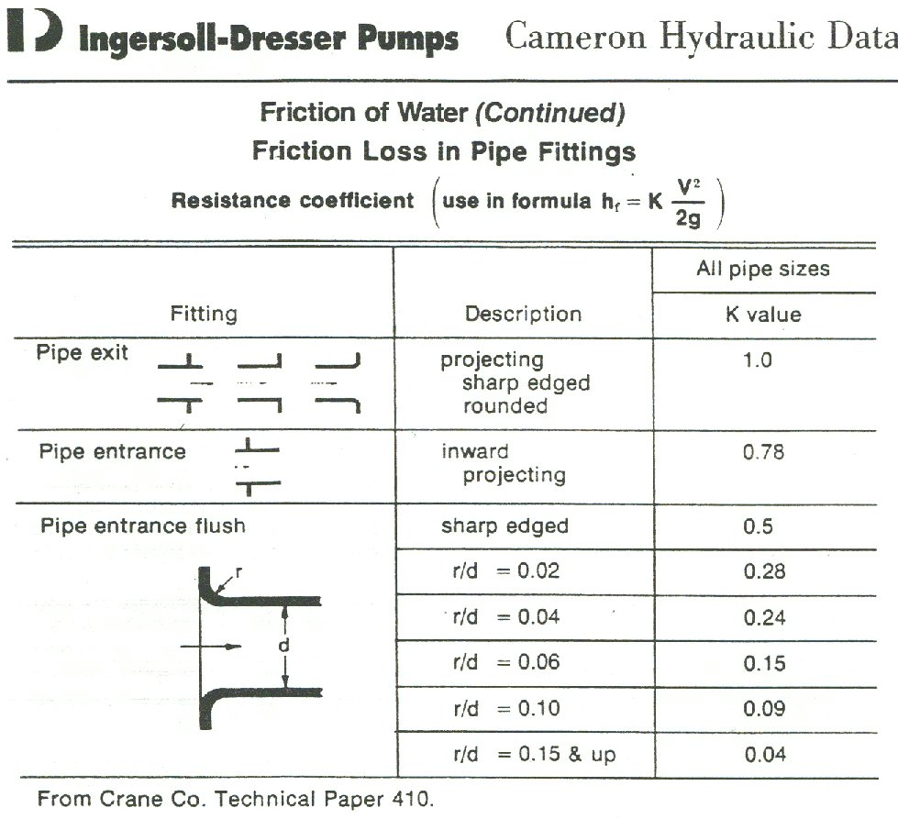
Figure 8 Entrance pressure head loss K coefficients (source Cameron Hydraulic data book).

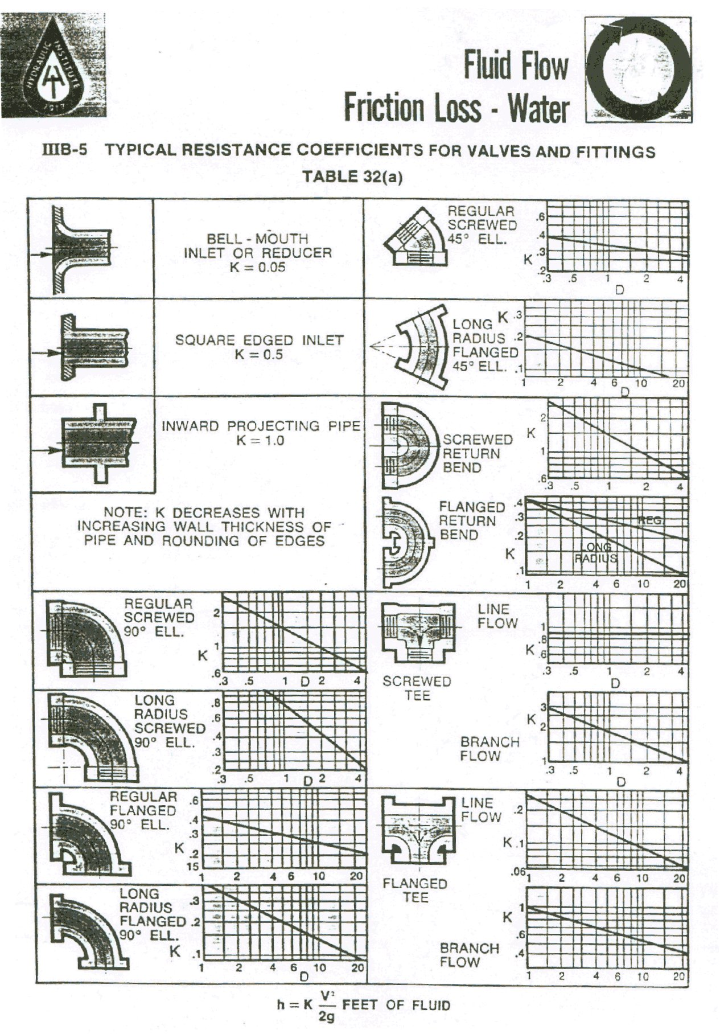
Figure 9 Pressure head loss K coefficients for fittings (source the Hydraulic Institute Standards book www.pumps.org).

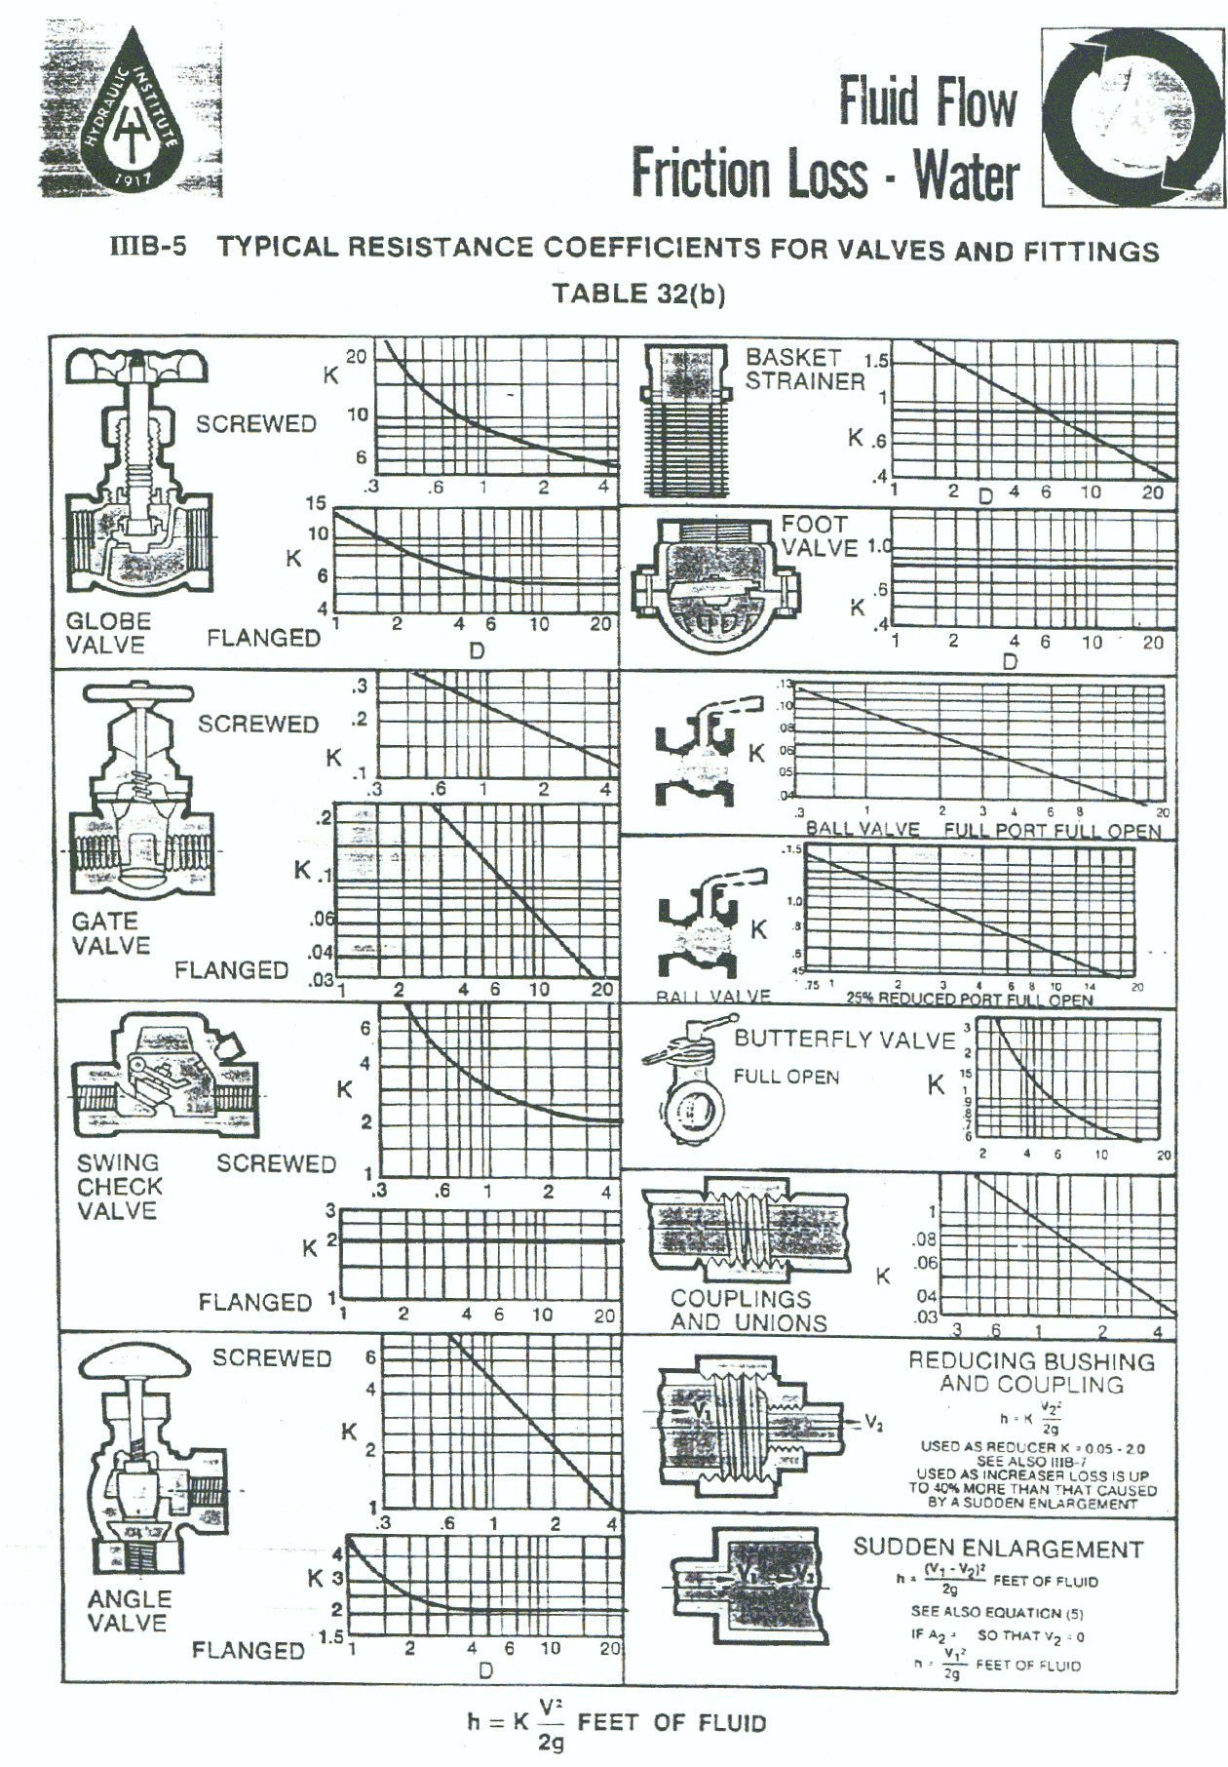
Figure 10 Pressure head loss K coefficients for manual valves and other devices (source the Hydraulic Institute Standards book www.pumps.org).

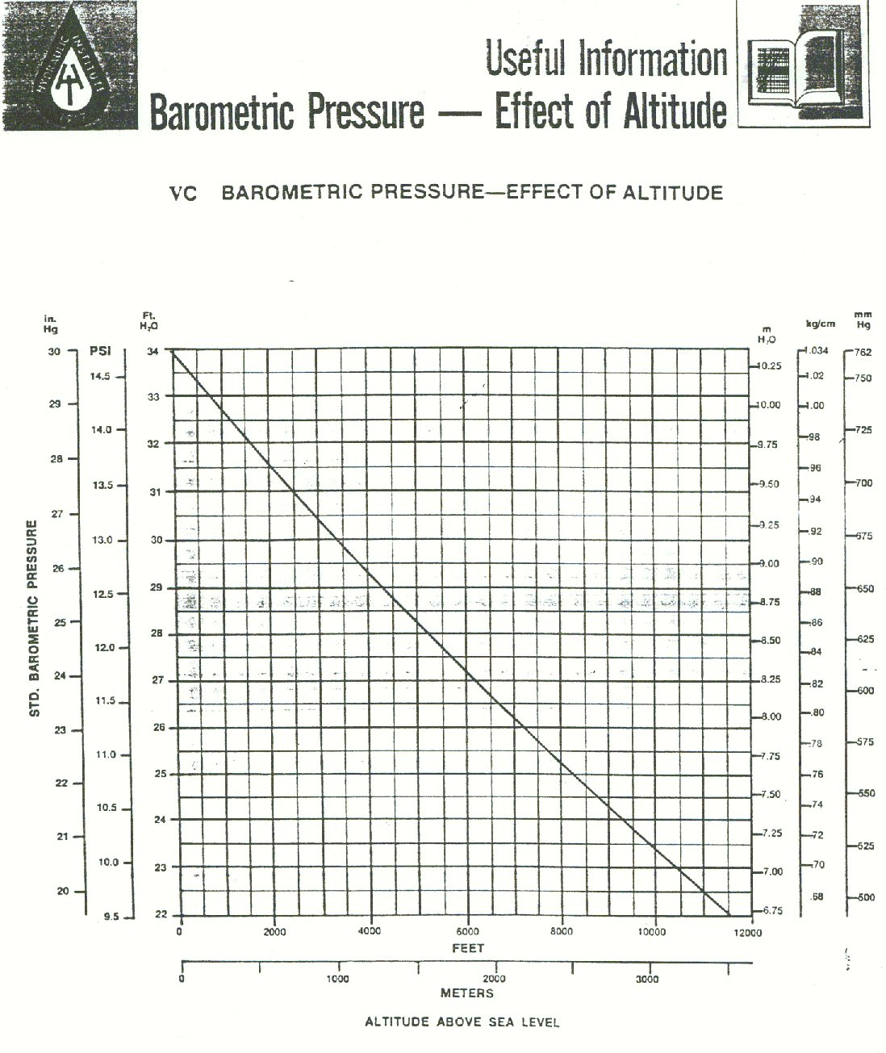
Figure 11 Atmospheric pressure vs. elevation (source the Hydraulic Institute Standards book www.pumps.org).

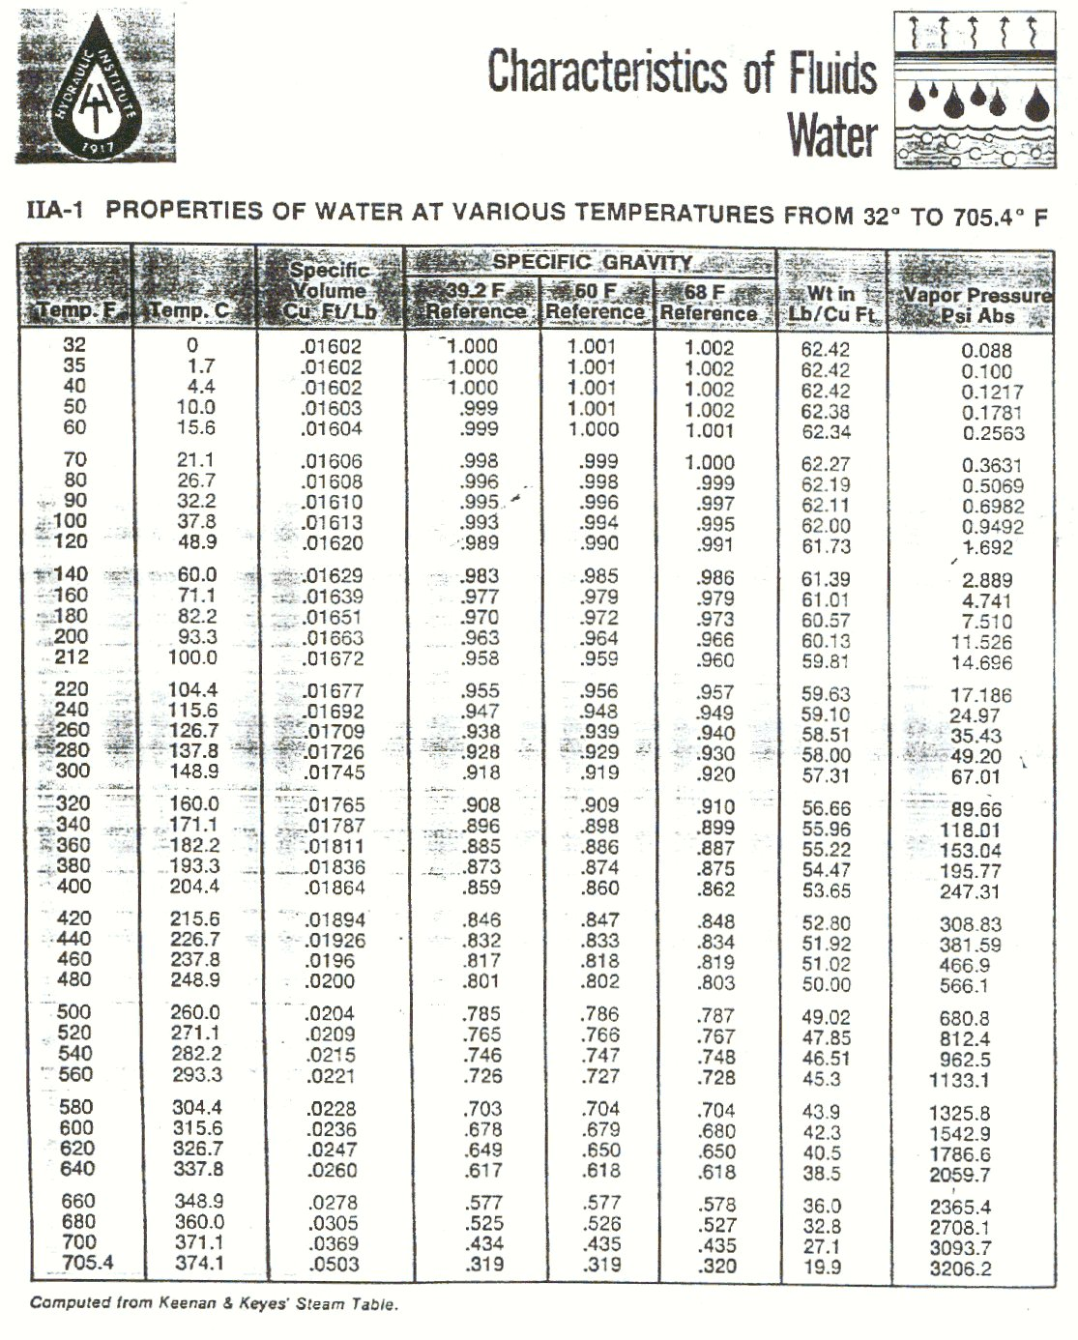
Figure 12 Properties of water (source the Hydraulic Institute Standards book www.pumps.org).

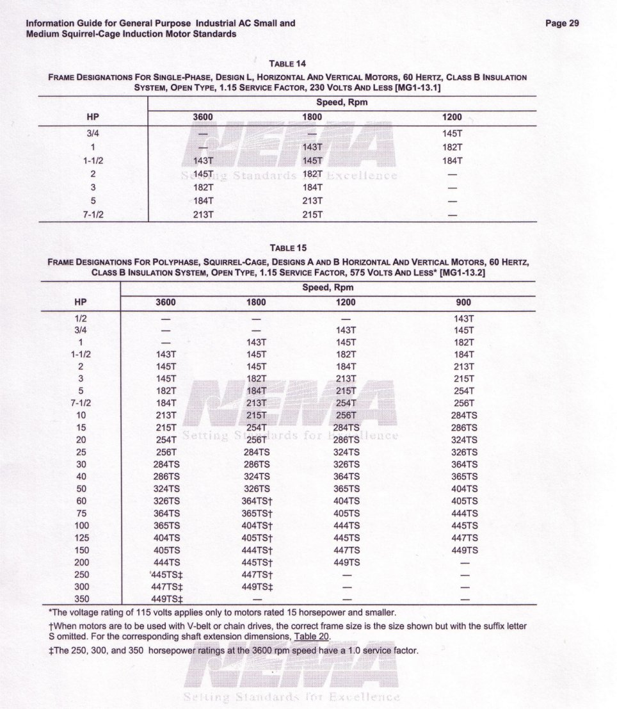
Figure 13 Electric motor frame NEMA standard designations with respect to horsepower.

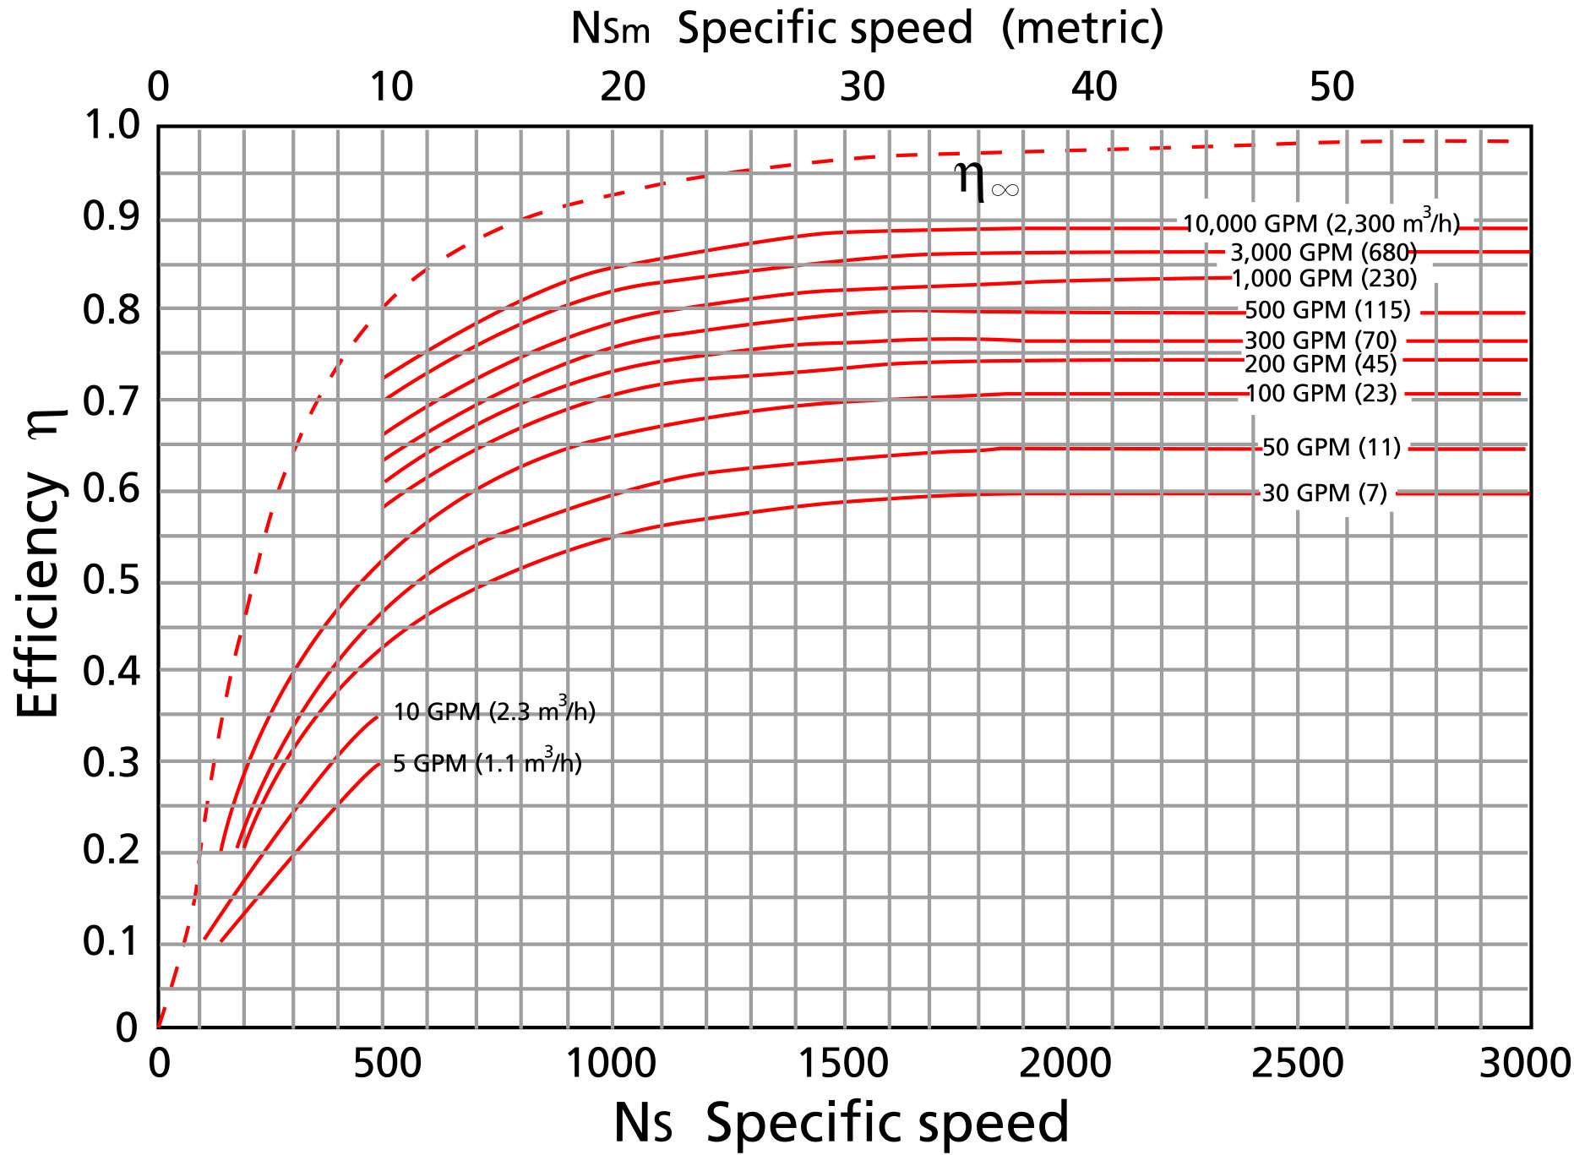
Figure 14 Efficiency values for pumps of similar construction at different specific speeds.

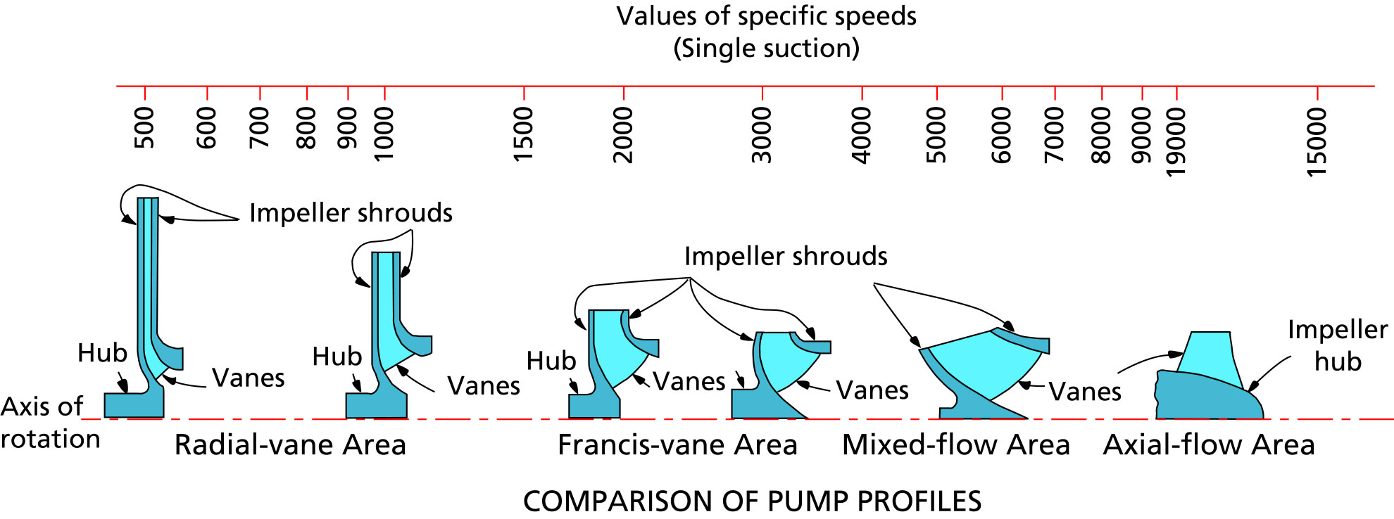
Figure 15 Specific speed values for the different pump designs.
(source: the Hydraulic Institute Standards book, see www.pumps.org)

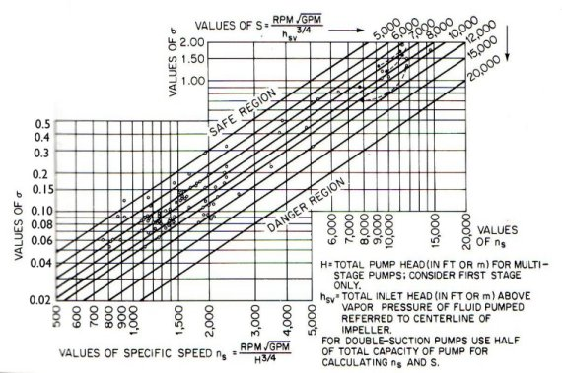
Figure 16 The Thoma number vs. specific speed and suction specific speed to predict cavitation (source: the Pump Handbook, McGraw-Hill).

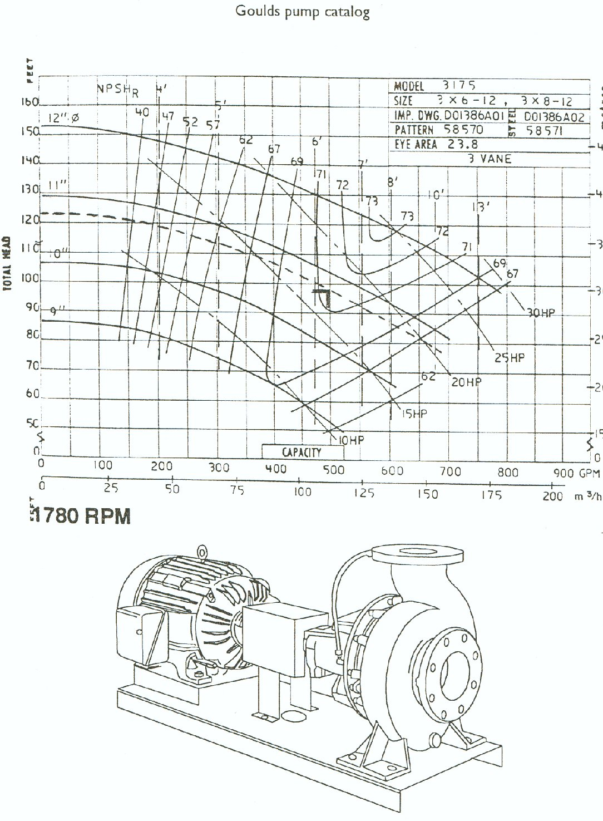
Figure 17 Selected pump characteristic curve (source the Gould pump catalogue www.goulds.com).

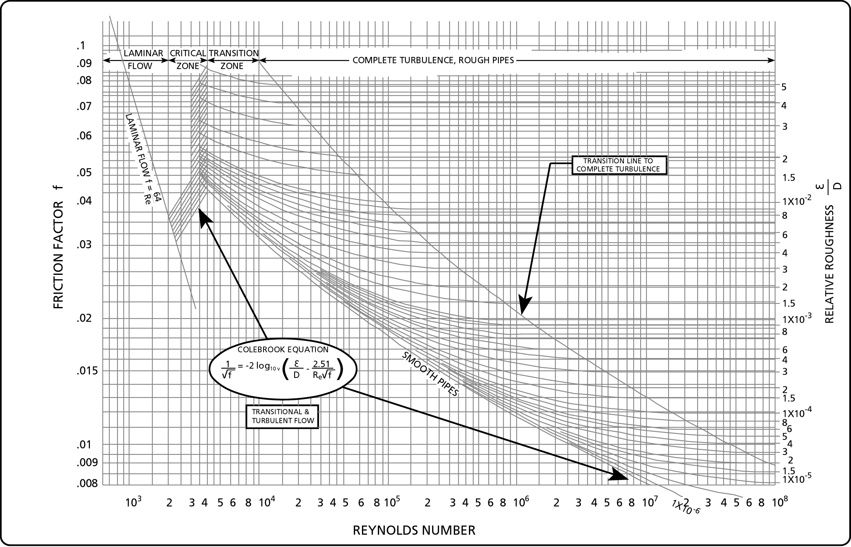
18 The Moody diagram, friction factor vs. Reynolds number for laminar and turbulent flow at various pipe roughness-values.

