HOW TO CALCULATE PRESSURE ANYWHERE IN A PUMP SYSTEM?
Jacques Chaurette p. eng.
www.lightmypump.com
April 2003

Synopsis

Calculating the total head of the pump is not the only task of the pump system designer. Often we need to know the pressure level at a specific point in the system. Suppose we have a system that transports a hot liquid, we know that hot liquids vaporize very easily under conditions of low pressure. There is a high point in our system where we know the pressure will be low but exactly how low? The techniques in this article will show you how to do this calculation for any point in the system.

Calculating the pump total head sometimes involves calculating the pressure in different parts of the system. For example, you may need to ensure that a given piece of equipment has a certain pressure level at its inlet to ensure proper operation. The manufacturer of the equipment will give this pressure level if it is critical. Or you may need to calculate the pressure level at the inlet of the control valve to verify its capacity. The position of this equipment as well as the length and size of the piping that is ahead of the equipment will affect this pressure level, which in turn will affect the total head of the pump. This article will show you how to determine the pressure anywhere in any system, which in turn will allow you to modify that pressure level and understand the impact on the pump.
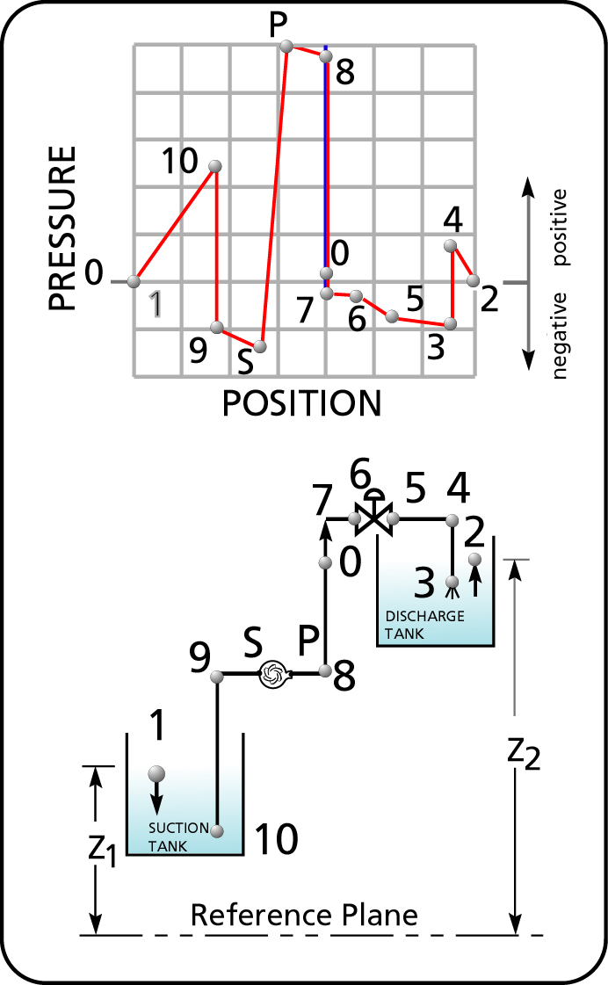
Figure 1 The pressure variation within a typical pumping system.

The system configuration in Figure 1 illustrates how drastically the pressure head can vary in a simple pumping system. The pressure just before the control valve is a parameter required to size the valve. It is calculated by the method described in this article. We will use the control valve as an example but this could be any piece of equipment.
Figure 2 shows a general representation of a pumping system. The variables z, H and v represent the conditions that affect the pump total head at point 1 (the inlet) and point 2 (the outlet of the system). z is the elevation, v the velocity of fluid particles and H the pressure head. H₁ and H₂ represent the pressure heads corresponding to the pressures in the tanks p₁ and p₂. If the tanks are open to atmosphere that H₁ and H₂ will equal zero.

It is always possible to calculate pressure head when the pressure is known using equation [1] where SG is the specific gravity of the fluid.

 | $$H (\text{ft} \text{fluid}) = \frac{2\text{.}\text{31} × p(\text{psi})}{\text{SG}}$$ | [1]

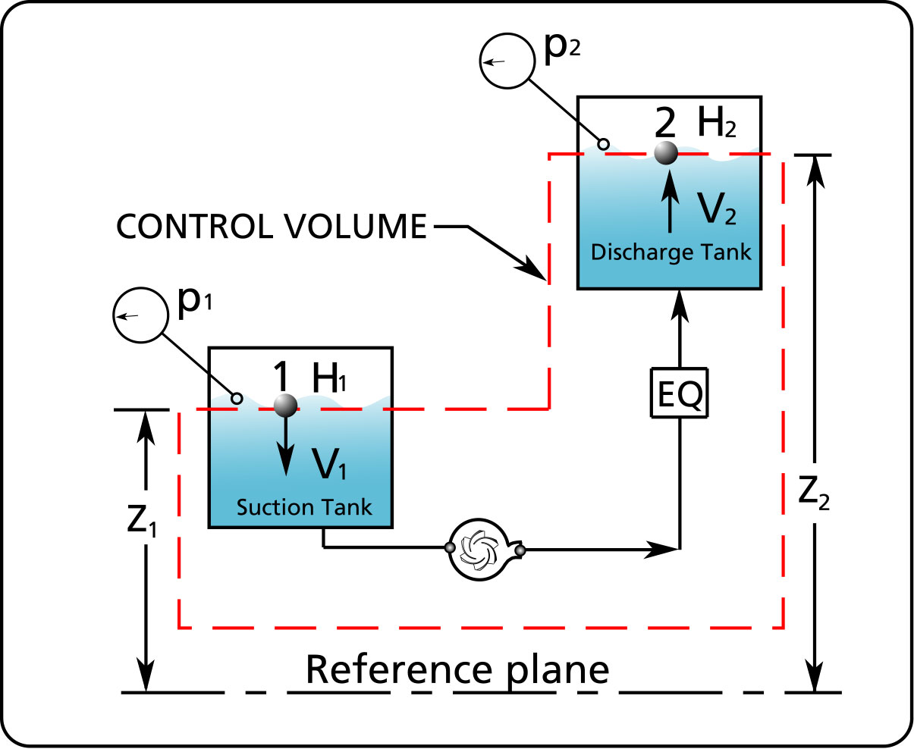
Figure 2 A general representation of a pumping system.

HOW TO CALCULATE THE PUMP TOTAL HEAD FROM THE ENERGY BALANCE

An energy balance can determine the total head of the pump or the energy required of the pump. The amount of energy that the pump must supply will be the difference in energy between the energies available at points 1 and 2 plus the piping and equipment friction loss in the system at the required flow rate. A very detail explanation of this is available in a book called “Pump System Analysis and Centrifugal Pump Sizing” by Jacques Chaurette and is available on the web sites http://www.lightmypump.com/pump_book.htmm.

The energy balance is:

 | $$\frac{({Dp}_{F1−2}+{Dp}_{\text{EQ}1−2})}{ρ\frac{g}{g_{c}}}−\frac{{Dp}_{P}}{ρ\frac{g}{g_{c}}}=\frac{(p_{1}−p_{2})}{ρ\frac{g}{g_{c}}}+\frac{1}{2g}(v_{1^{2}}−v_{2^{2}})+(z_{1}−z_{2})$$ | [2]
Equation [2] is Bernoulli’s equation with the pump pressure increase (p_{P}) and fluid friction loss due to piping (p_{F1-2}) and equipment (p_{EQ1-2}) friction terms added. Pressure can be expressed in terms of fluid column height or pressure head.
 | $$p=\frac{ρ\text{gH}}{g_{c}}$$ | [3]
All pressure terms in equation [2] are replaced by their corresponding fluid column heights, with the use of equation [3]
$p_{1}=\frac{ρ{\text{gH}}_{1}}{g_{c}}$, ${Dp}_{F1−2}=\frac{{ρgDH}_{F1−2}}{g_{c}}$, etc.). The constant (g_{c}) cancels out.

The total head of the pump is:

$${ΔH}_{P}(\text{ft}\text{fluid})=({ΔH}_{F1−2}+{ΔH}_{\text{EQ}1−2})+\frac{1}{2g}(v_{2^{2}}−v_{1^{2}})+z_{2}+H_{2}−(z_{1}+H_{1})$$ | [4]

The unit of total head (ΔH_{P}) is feet of fluid in the Imperial system and meters of fluid in the metric system. (See the variable nomenclature table at the end of the article for the meaning of the variables in this article)

CALCULATE THE PRESSURE HEAD ANYWHERE ON THE DISCHARGE SIDE OF THE PUMP

Equation [4] is the result of an energy balance between points 1 and 2. The same process of making an energy balance can be applied between any two points for example points 1 and X (see Figure 3). We can do an energy balance between points 1 and point X and since we know the value of the total head ΔH_{P} we can calculate the conditions at point X.

First, calculate the total head for the complete system using equation [4]. Next, a control volume (CONTROL VOLUME 1) is positioned to intersect point X and point 1 (see Figure 3). Point X can be located anywhere between P and 2. The system equation (equation [4]) can be used with point X as the outlet instead of point 2. It is then resolved for the unknown variable H_{x} instead of ΔH_{P}.

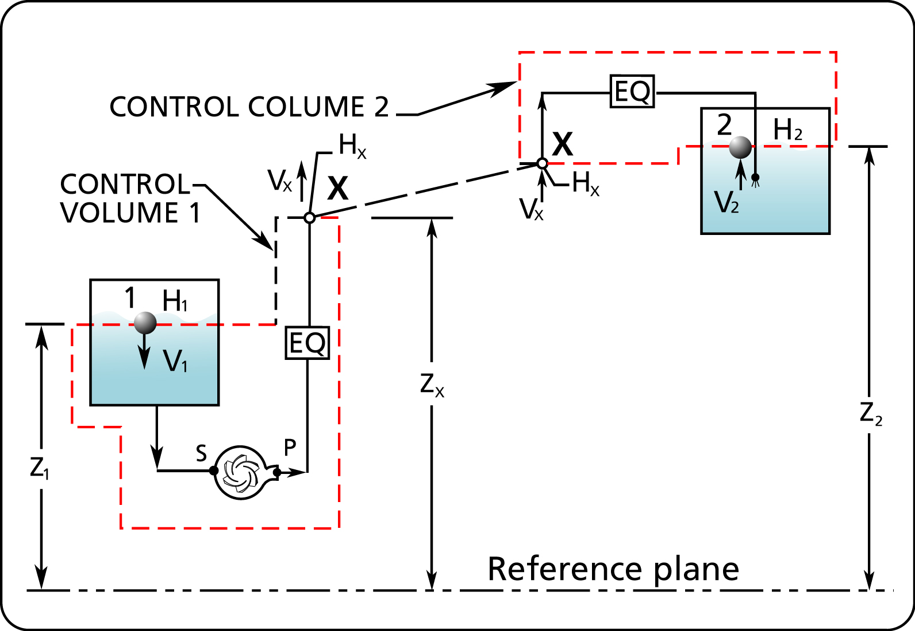
Figure 3 The control volume determines where the conditions on the discharge side of the pump can be calculated.
Equation [4] gives the total head for the complete system and is repeated here:

$${ΔH}_{P} = ({ΔH}_{F1−2}+{ΔH}_{\text{EQ} 1−2}) + \frac{1}{2g}(v_{{{}_{2}}^{2}}−v_{{}_{1}^{2}}) + (z_{{}_{2}}+H_{2} − (z_{{}_{1}}+H_{1})$$
Equation [4] is applied with the following changes: all terms with subscript 2 are replaced with the subscript X, H₂=H_{X}, ΔH_{F1-2} = ΔH_{F1-X} , ΔH_{EQ1-2} = ΔH_{EQ1-X,} v₂ = v_{X,} z₂ = z_{X.} The unknown term Hx is isolated on one side of the equation and we obtain equation [5].

 | $$H_{X}={DH}_{P}−({DH}_{F1−X}+{DH}_{\text{EQ}1−X})+\frac{1}{2g}(v_{1^{2}}−v_{X^{2}})+(z_{1}+H_{1}−z_{X})$$ | [5]

The unknown pressure head (H_{x}) can also be determined by using that part of the system defined by control volume 2 (see Figure 3) by using the same reasoning as above, in equation [4], ΔH_{P} = 0 and all terms with subscripts 1 replaced with X. Therefore, H₁=H_{X}, ΔH_{F1-2} = ΔH_{FX-2} , ΔH_{EQ1-2} = ΔH_{EQX-2,} v₁= v_{X,} z₁ = z_{X} The unknown term Hx is isolated on one side of the equation and we obtain equation [6].

 | $$H_{X}=({DH}_{\text{FX}−2}+{DH}_{\text{EQX}−2})+\frac{1}{2g}(v_{2^{2}}−v_{X^{2}})+(z_{2}+H_{2}−z_{X})$$ | [6]

We now have two methods for determining the pressure head at any location. We can use one equation to verify the results of the other. The calculation of H_{X} is often quicker when using equation [6].

Note that in equation [6] the value of ΔH_{P} is not required to calculate H_{x}.

CALCULATE THE PRESSURE HEAD ANYWHERE ON THE SUCTION SIDE OF THE PUMP

We can determine the pressure head anywhere on the suction side of the pump by the same method. In this case, ΔH_{P} = 0 since there is no pump within the control volume (see Figure 4). ΔH_{P} = 0 and subscript 2 is replaced with subscript X in equation [4]. The unknown term Hx is isolated on one side of the equation and we obtain equation [7].

 | $$H_{X} = − ({ΔH}_{F1−X}+{ΔH}_{\text{EQ}1−X}) + \frac{1}{2g}(v_{1^{2}}−v_{X^{2}}) + (z_{1}+H_{1}−z_{X})$$ | [7]

The velocity (v_{X}) must be the same as the one at point X in the complete system. Equation [6] is important in calculating the N.P.S.H. available and avoiding cavitation. You can find an article that treats this subject specifically at http://www.lightmypump.com/downloads-free.htm#download12.

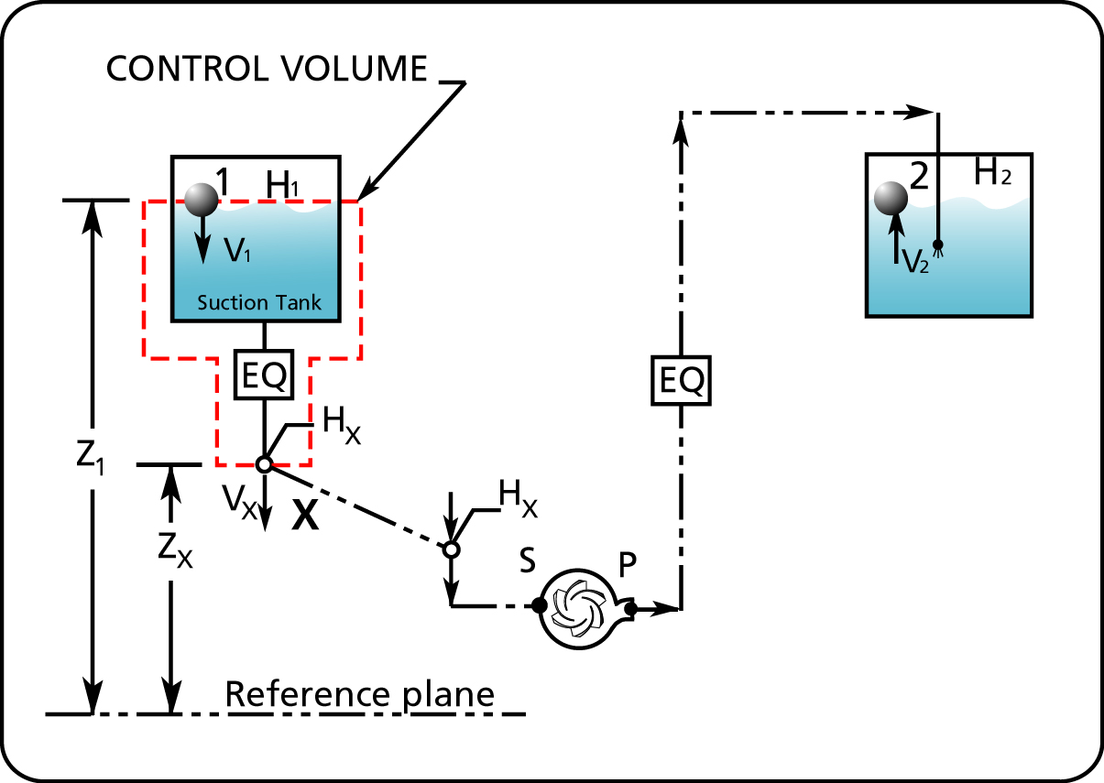
Figure 4 The control volume determines where the conditions on the suction side of the pump can be calculated.

Let’s do a practical example, suppose you have a piece of equipment that requires 30 psig pressure at its inlet to function properly. This has happened to me, the equipment was a Voith Turbo-Cleaner and Voith specified that the cleaner needed 30 psig pressure at its inlet. The system is shown in Figure 5.

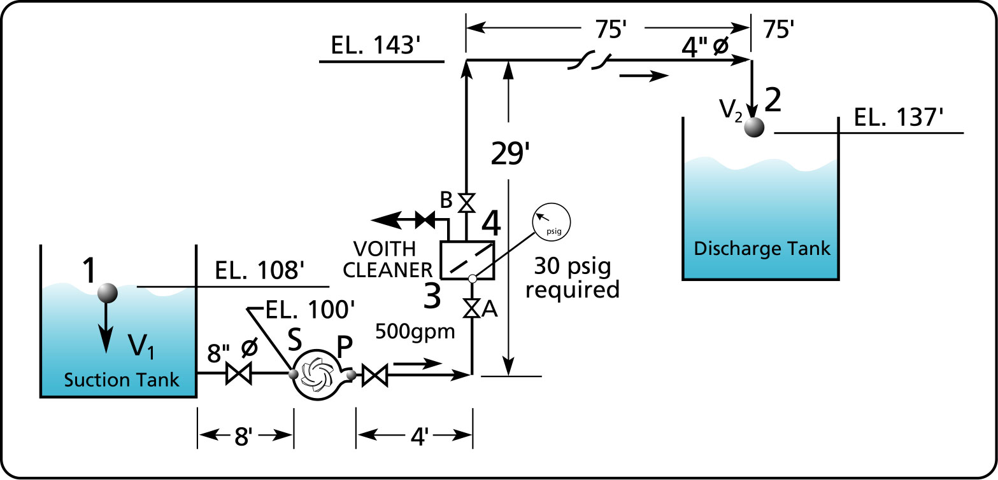
Figure 5 A system that requires a specified pressure at the inlet of an equipment.

I calculated the total head of the pump using equation [4] without taking into account the inlet pressure requirement of the cleaner and obtained a value of 70 feet of fluid. You will have to take my word for this, as you do not have enough information to do the calculation, for example you are missing the pressure drop across the cleaner, the properties of the fluid, etc.

Using equation [5], I calculated the pressure head at the inlet of the cleaner (point 3) to be 40 feet that corresponds to 17 psig. This is clearly smaller than required by the manufacturer. There are several options to correct this, the main ones are:

- If the system is in the design stage, reposition the cleaner to increase the pressure at the inlet. If this is impractical then

- Close the manual valve B (see Figure 5) at the outlet of the cleaner (point 4) to increase the pressure at the inlet (point 3).

You cannot close the valve on an existing system that has not been designed for the additional pressure required at the cleaner inlet. To do so would reduce the flow and that is not acceptable. You must deal with this during the initial stages of design or if the installation is already in operation modify the pump.

The pressure required (30 psig) at the cleaner inlet corresponds to (use equation [1]) 69 feet of pressure head. Prior to applying this requirement, I calculated that the pressure head at point 3 was 40 feet, we are missing 29 feet. We must now calculate the total head of the pump that will produce the value of 69 feet at point 3 at the flow rate required. Using equation [5] and with the value of H_{X} (69 feet), we can then calculate the value of ΔH_{P}, the total head of the pump, which will satisfy the requirements.

Symbols

Variable nomenclature | Imperial system  (FPS units) | Metric system  (SI units)
H head | ft (feet) | m (meter)
ΔH_{P} Total Head | ft (feet) | m (meter)
ΔH_{EQ} equipment friction head loss | ft (feet) | m (meter)
ΔH_{F} friction head loss in pipes | ft (feet) | m (meter)
p pressure | psi (pound per square inch) | kPa (kiloPascal)
SG specific gravity; ratio of the fluid density to the density of water at standard conditions | non-dimensional
v velocity | ft/s (feet/second) | m/s (metre/second)
z vertical position | ft (feet) | m (meter)

