CENTRIFUGAL PUMP SPECIFIC SPEED PRIMER AND THE AFFINITY LAWS
Jacques Chaurette p. eng.
www.lightmypump.com
November 2004

There is a number called the specific speed of a pump whose value tells us something about the type of pump. Is it a radial type pump which provides high head and low flow or an axial or propeller type pump which provides low flow but high head or something in between. If you are worried whether you have the right type of pump or not this number will help you decide. The article gives you an example of how to calculate this number. Also if you are worried that your pump may be cavitating there is another number related to specific speed called suction specific speed that will help you diagnose and avoid cavitation.

There is a multitude of pump designs that are available for any given task. Pump designers have needed a way to compare the efficiency of their designs across a large range of pump model and types. Pump users also would like to know what efficiency can be expected from a particular pump design. For that purpose pump have been tested and compared using a number or criteria called the specific speed (N_{S}) which helps to do these comparisons. The efficiency of pumps with the same specific speed can be compared providing the user or the designer a starting point for comparison or as a benchmark for improving the design and increase the efficiency. Equation [1] gives the value for the pump specific speed, H is the pump total head, N the speed of the impeller and Q the flow rate.

 | $$N_{S} = \frac{n(\text{rpm}) × \sqrt{Q(\text{USgpm})}}{H(\text{ft} \text{fluid})^{0\text{.}\text{75}}}$$ | [1]
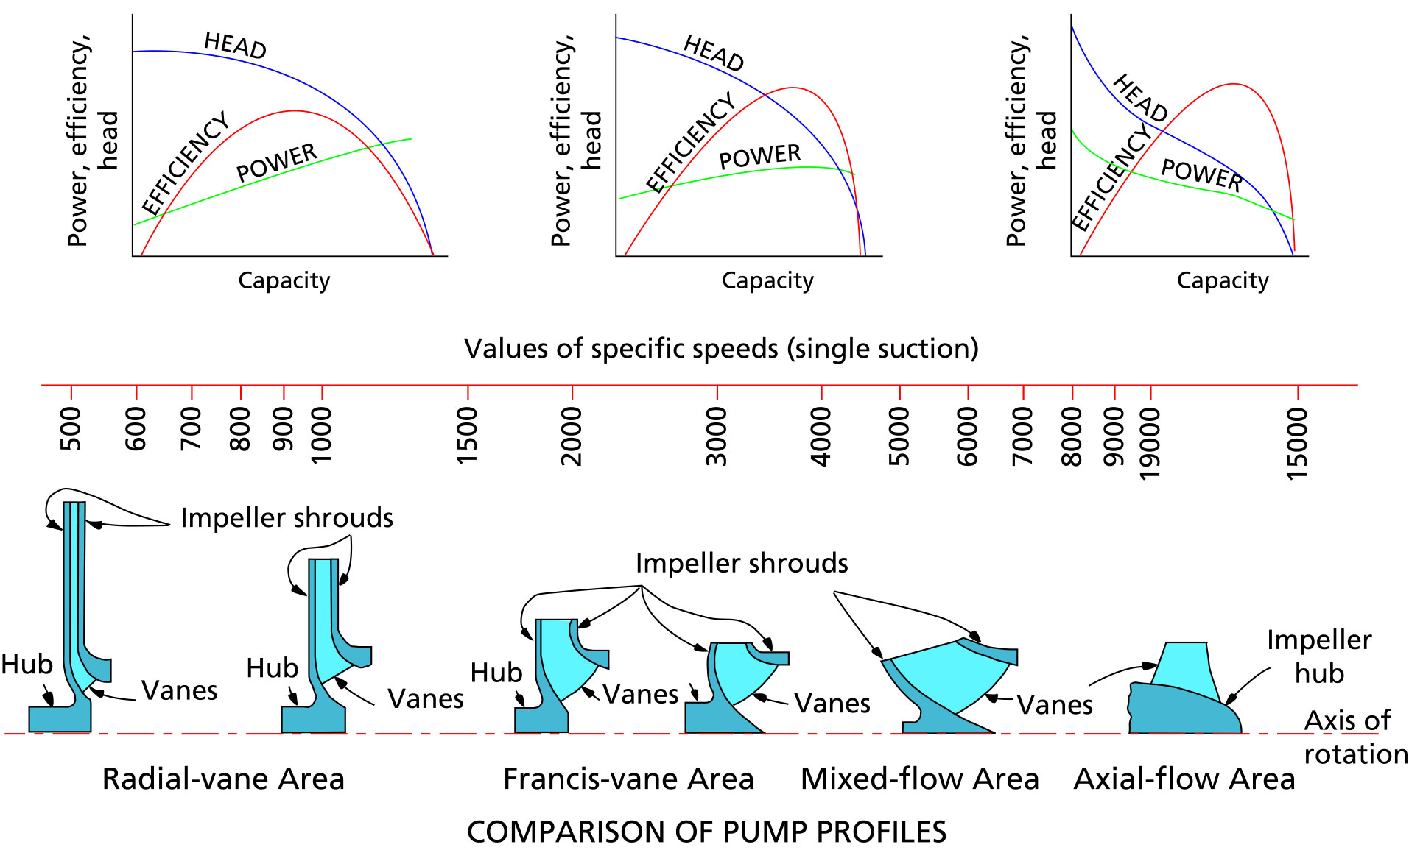
Figure 1 Specific speed values for the different pump designs.
(source: the Hydraulic Institute Standards book, see www.pumps.org)

Pumps are traditionally divided into 3 types, radial flow (see Figure 2), mixed flow (see Figure 3) and axial flow (see Figure 4). There is a continuous change from the radial flow impeller, which develops pressure principally from the action of centrifugal force, to the axial flow impeller, which develops most of its head by the propelling or lifting action of the vanes on the liquid.
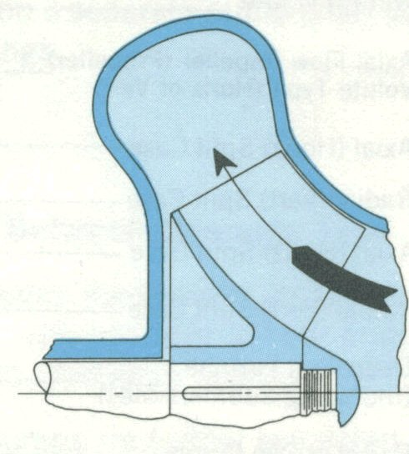
Figure 3 Mixed flow pump cross-section, (source: Hydraulic Institute www.pumps.org).

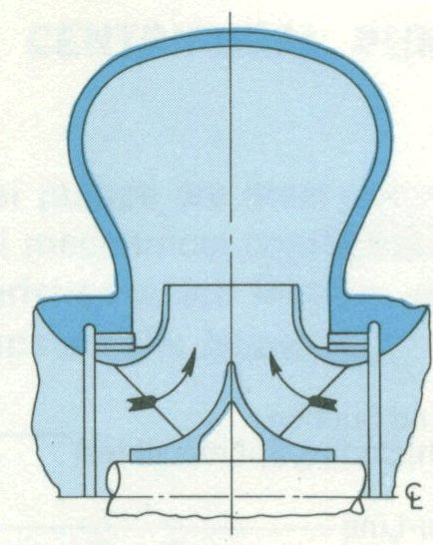
Figure 2 Radial flow pump cross-section, (source: Hydraulic Institute www.pumps.org).
Specific speed has also been used as a criteria for evaluating the efficiency of standard volute pumps (see Figure 5). Notice that larger pumps are inherently more efficient and that efficiency drops rapidly at specific speeds of 1000 or less.
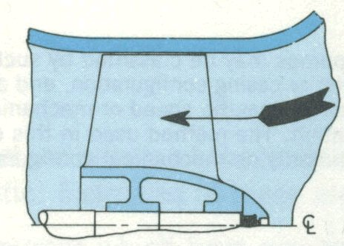

Figure 4 Axial flow pump cross-section, (source: Hydraulic Institute www.pumps.org).

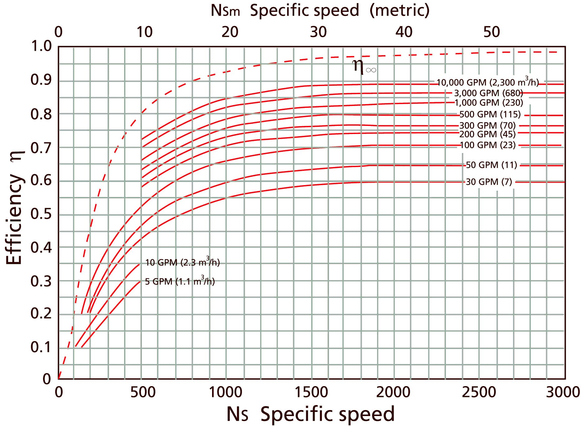
Figure 5 Efficiency values for pump with different specific speeds (source: The Pump Handbook published by McGraw Hill).

The following chart provides the efficiency data for pumps of various types vs the flow rate and maybe easier to read than Figure 5. However some corrections are required (use the chart in the upper left corner of Figure 6) to the values predicted.

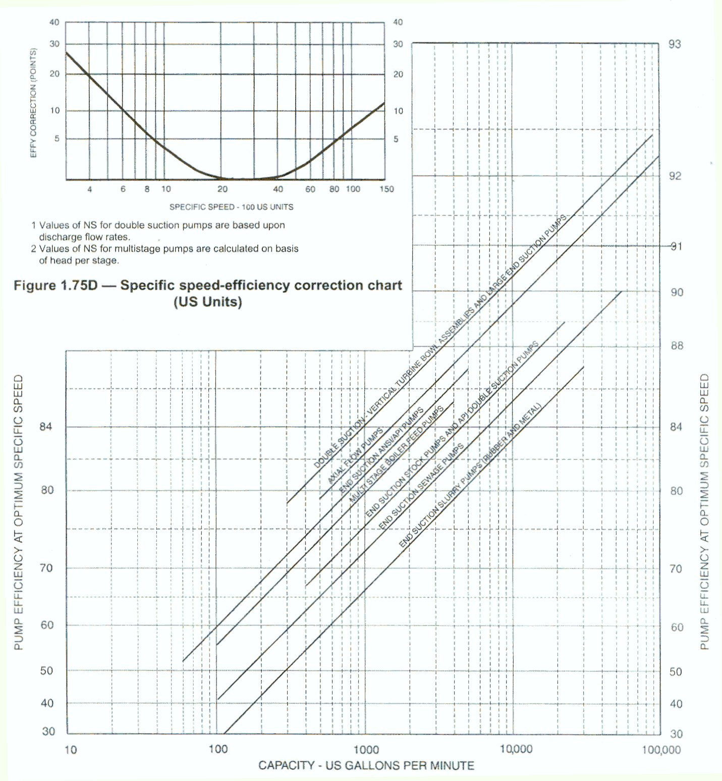
Figure 6 Efficiency values for pumps of different types (source: The Hydraulic Institute www.pumps.org).

Let’s take an example, we have selected a Goulds pump Model 3175 which will provide us with a head of 97 feet at a flow rate of 500 USgpm, what is the specific speed? The efficiency of this pump according to the Goulds performance curve (see Figure 6) is 71.5%.

The chart in Figure 5 predicts that the efficiency should be 78% for a specific speed of 1266, this is a fair difference, perhaps Goulds would suggest another pump as an alternative.
 | $$N_{S} = \frac{n(\text{rpm}) × \sqrt{Q(\text{USgpm})}}{H(\text{ft} \text{fluid})^{0\text{.}\text{75}}} =\frac{\text{1750} x \sqrt{\text{500}}}{{\text{97}}^{0\text{.}\text{75}}} = \text{1266}$$ | [2]

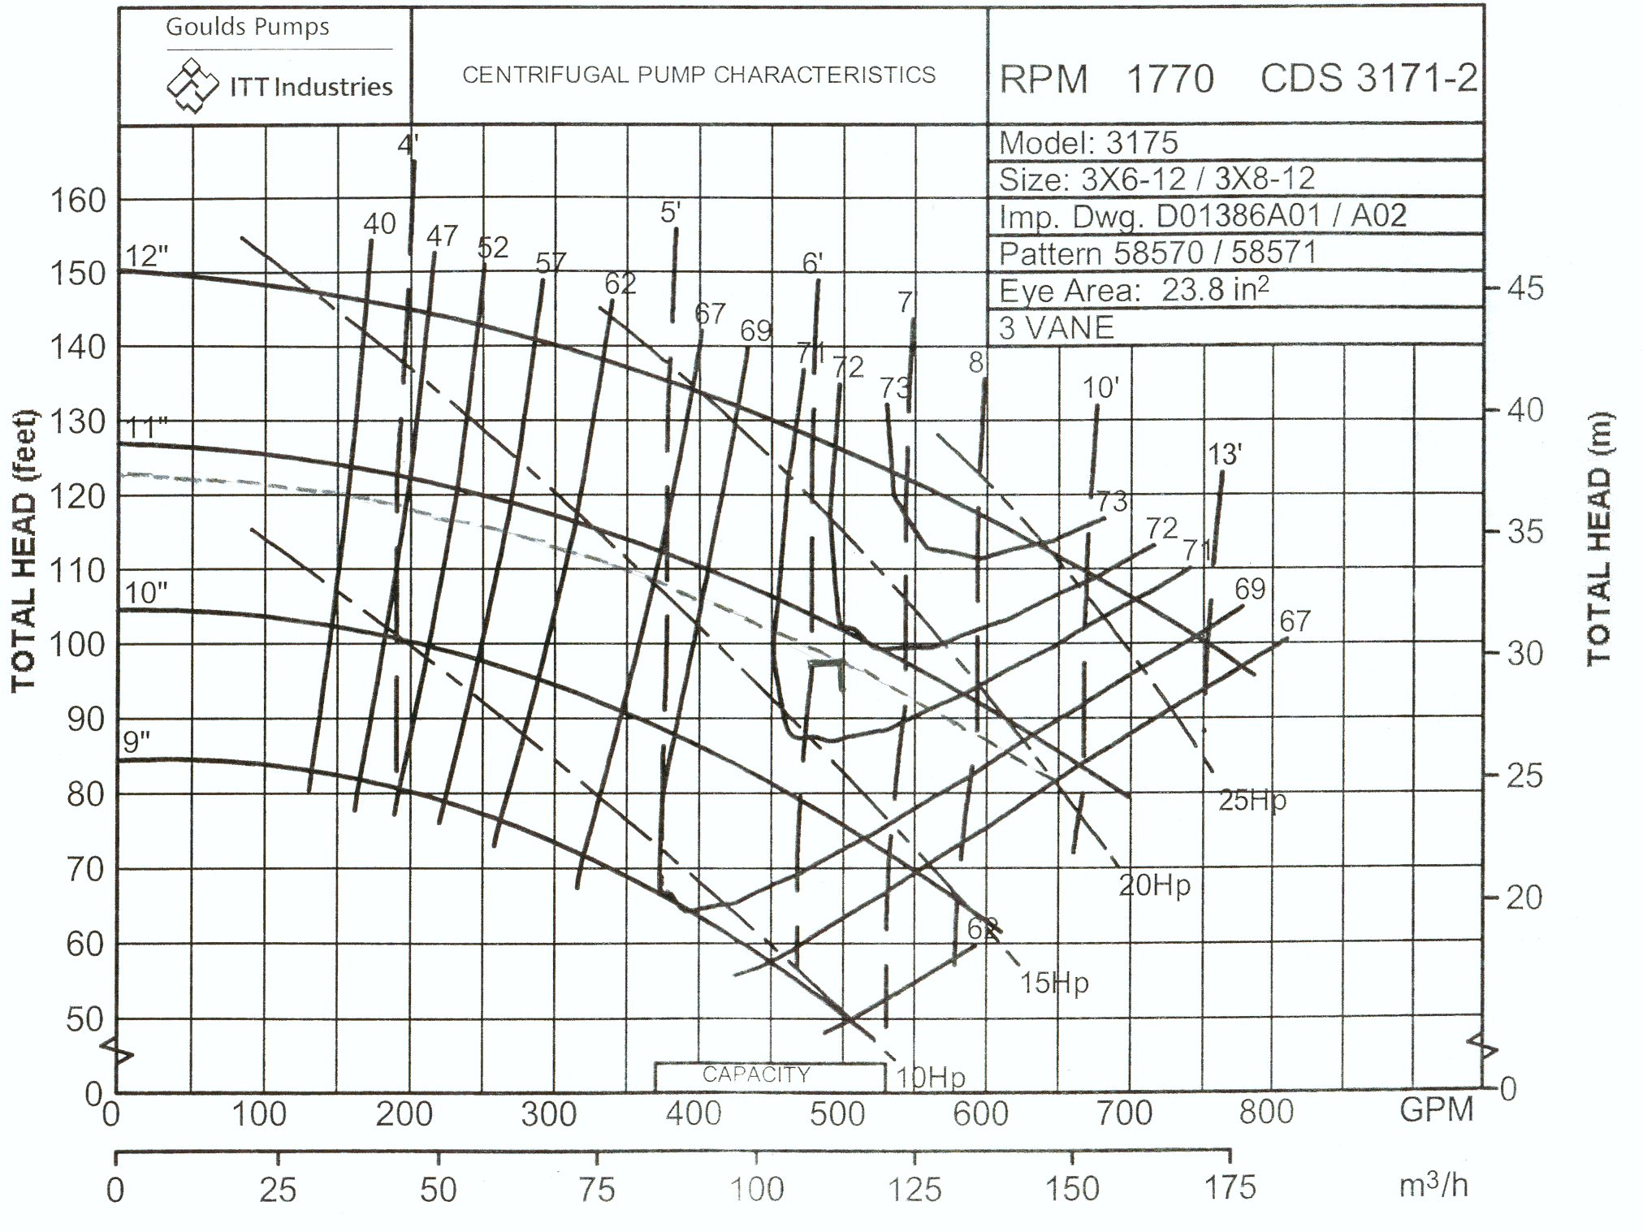
Figure 7 Goulds characteristic curves for a model 3175 3X6-12 pump at 1770 rpm (from the Goulds pump catalogue).

SUCTION SPECIFIC SPEED

Suction specific speed is a number that is dimensionally similar to the pump specific speed and is used as a guide to prevent cavitation.

 | $$S = \frac{n(\text{rpm}) × \sqrt{Q(\text{USgpm})}}{N\text{.}P\text{.}S\text{.}H{\text{.}}_{A}(\text{ft} \text{fluid})^{0\text{.}\text{75}}}$$ | [3]
Instead of using the total head of the pump H, the N.P.S.H._{A} (Net Positive Suction Head available) is used. Also if the pump is a double suction pump then the flow value to be used is one half the total pump output.

From the previous article on cavitation, the N.P.S.H._{A} at the pump suction is :

$$N\text{.}P\text{.}S\text{.}H{\text{.}}_{\text{avail}\text{.}}(\text{ft} \text{}\text{fluid} \text{absol} \text{.} ) = − ({ΔH}_{F1−S}+{ΔH}_{\text{EQ}1−S})+\frac{v_{{{}_{1}}^{2}}}{2g}+(z_{{}_{1}} − z_{{}_{S}}+H_{1})+H_{A}−H_{\text{va}}$$ | [4]

where H_{A} and H_{va} are in feet of fluid. Equation [4] requires that the piping (ΔH_{F1-S}) friction loss and equipment friction loss (ΔH_{EQ1-S}) be calculated. The meaning of some of the variables in equation [4] are shown in Figure 8.

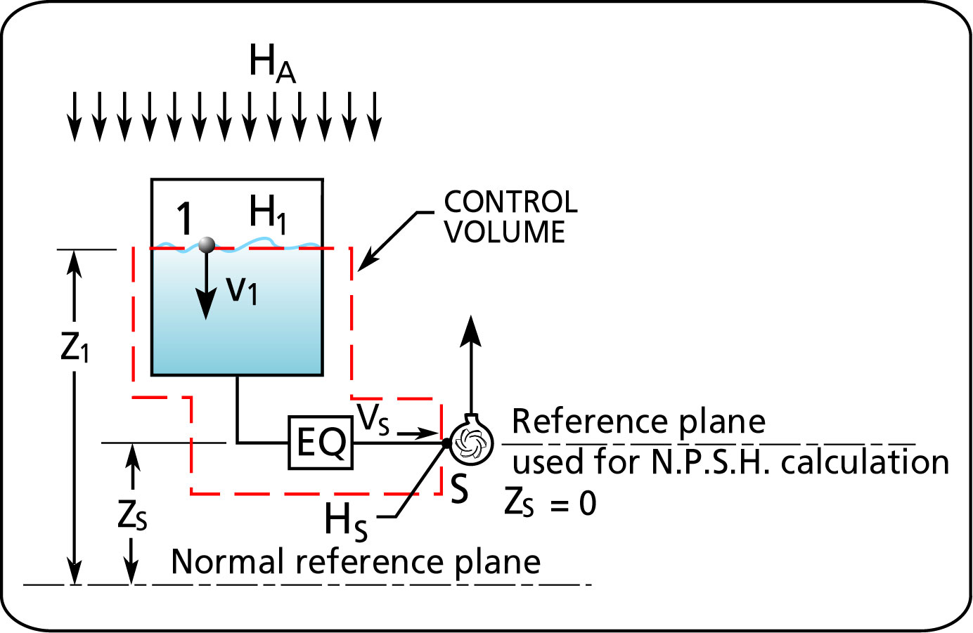
Figure 8 Meaning of the variables used for calculating the N.P.S.H._{A}.

We can avoid doing the calculations for equation [4] by measuring the N.P.S.H.. The value for the N.P.S.H._{A} can be deduced by taking a pressure measurement at the pump inlet and using equation [5]

 | $$N\text{.}P\text{.}S\text{.}H\text{.} \text{avail}(\text{ft} \text{fluid} \text{absol}\text{.}) = 2\text{.}\text{31} \frac{p_{{}_{\text{GS}}}(\text{psig}) }{\text{SG}} + z_{{}_{\text{GS}}}− z_{{}_{S}} + \frac{v_{S}^{2}}{2 g} + H_{A} +H_{\text{va}}$$ | [5]

The meaning of some of the variables in equation [5] are shown in Figure 9.

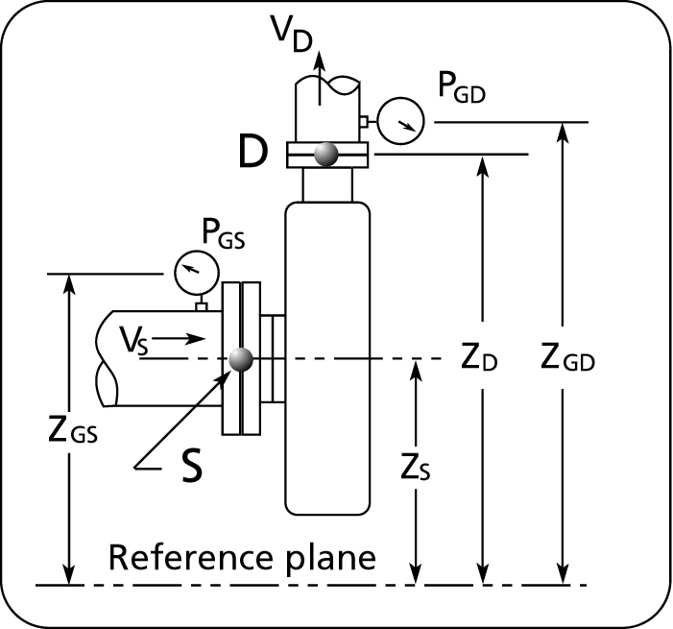

Figure 9 Location of variables for measuring N.P.S.H._{A}.

We may be considering an increase in the pump’s speed to increase the flow rate. If so, be aware that an increase in speed will also require an increase in N.P.S.H. required. The suction specific speed value give us an indication of what the impeller speed limitation will be for a given N.P.S.H._{A} . The Hydraulic Institute recommends that the suction specific speed be limited to 8500 to avoid cavitation. Other experiments have shown that the suction specific speed could be as high as 11000.

In the previous example the N.P.S.H._{A} of the pump was determined to be 15 feet absolute. Therefore the suction specific speed will be 5130.

 | $$S = \frac{n(\text{rpm}) × \sqrt{Q(\text{USgpm} )}}{N\text{.}P\text{.}S\text{.}H{\text{.}}_{A}(\text{ft} \text{fluid})^{0\text{.}\text{75}}} =\frac{\text{1750} x \sqrt{\text{500}}}{{\text{15}}^{0\text{.}\text{75}}} = \text{5130}$$ | [6]

This is well below 8500. We can easily calculate the new suction specific speed if we were to change the impeller speed.

When a pump has a high suction specific speed value, it can mean that the impeller inlet area is large reducing the inlet velocity which is needed to enable a low NPSHR. However, if you continue to increase the impeller inlet area (to reduce NPSHR), you will reach a point where the inlet area is too large resulting in suction recirculation (hydraulically unstable causing vibration, cavitation, erosion etc..). The recommended cap on the S value is to avoid reaching that point. (paragraph contributed by Mike Tan of the pump forum group).

Keeping the suction specific speed below 8500 is also a way of determining the maximum speed of a pump and avoiding cavitation. For a double suction pump, half the value of Q is used for calculating the suction specific speed.

According to the Hydraulic Institute the efficiency of the pump is maximum when the suction specific speed is between 2000 and 4000. When S lies outside this range the efficiency must be de-rated according to the following figure.

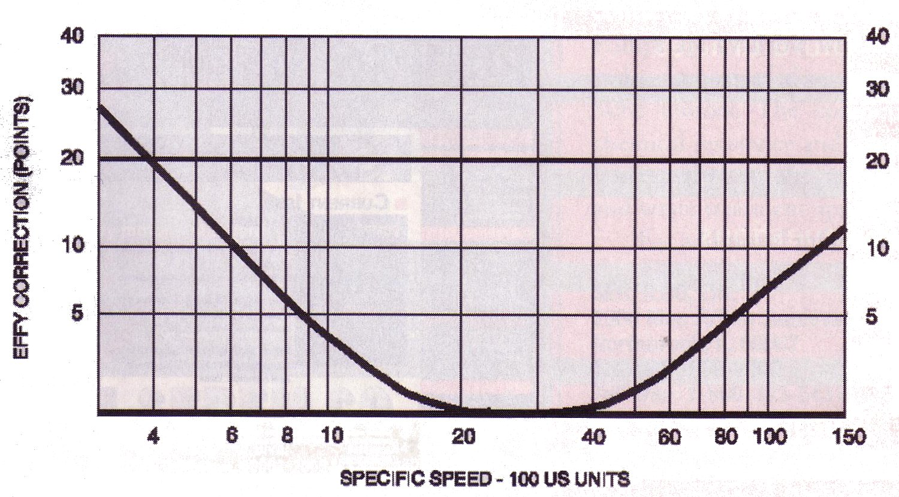

Figure 10 Pump efficiency correction due to suction specific speed.

AFFINITY LAWS

The affinity laws are derived from a dimensionless analysis of three important parameters that describe pump performance: flow, total head and power (ref: The Pump Handbook by McGraw-Hill, chapter 2). The analysis is based on the reduced impeller being geometrically similar and operated at dynamically similar conditions or equal specific speed. If that is the case then the affinity laws can be used to predict the performance of the pump at different diameters for the same speed or different speed for the same diameter. Since in practice impellers of different diameters are not geometrically identical, the author's of the section called Performance Parameters in the Pump Handbook recommend to limit the use of this technique to a change of impeller diameter no greater than 10 to 20%. In order to avoid over cutting the impeller, it is recommended that the trimming be done in steps with careful measurement of the results. At each step compare your predicted performance with the measured one and adjust as necessary.

The affinity laws were developed using the law of similitudes which provide 3 basic relationships.

Flow vs. diameter and speed

$$\frac{Q}{{\text{nD}}^{3}} = K$$ | or | $$\frac{Q_{1}}{Q_{2}} = \frac{n_{1}}{n_{2}} \frac{D_{1^{3}}}{D_{2^{3}}}$$

Total Head vs. diameter and speed

$$\frac{g H}{n^{2} D^{2}} = K$$ | or | $$\frac{H_{1}}{H_{2}} = \frac{n_{1^{2}}}{n_{2^{2}}} \frac{D_{1^{2}}}{D_{2^{2}}}$$

Power vs. diameter and speed

$$\frac{P}{\frac{γ}{g} n^{3}D^{5}} = K$$ | or | $$\frac{P_{1}}{P_{2}} = \frac{n_{1^{3}}}{n_{2^{3}}}\frac{D_{1^{5}}}{D_{2^{5}}}$$

where subscripts 1 and 2 denote the value before and after the change. P is the power, n the speed, D the impeller diameter, H the total head.

If the speed is fixed the affinity laws become:

$$\frac{Q_{1}}{Q_{2}} = \frac{D_{1^{3}}}{D_{2^{3}}}$$ |  | $$\frac{H_{1}}{H_{2}} = \frac{D_{1^{2}}}{D_{2^{2}}}$$ |  | $$\frac{P_{1}}{P_{2}} = \frac{D_{1^{5}}}{D_{2^{5}}}$$

If the diameter is fixed the affinity laws become:

$$\frac{Q_{1}}{Q_{2}} = \frac{n_{1}}{n_{2}}$$ |  | $$\frac{H_{1}}{H_{2}} = \frac{n_{1^{2}}}{n_{2^{2}}}$$ |  | $$\frac{P_{1}}{P_{2}} = \frac{n_{1^{3}}}{n_{2^{3}}}$$

The process of arriving at the affinity laws assumes that the two operating points that are being compared are at the same efficiency. The relationship between two operating points, say 1 and 2, depends on the shape of the system curve (see Figure 11). The points that lie on system curve A will all be approximately at the same efficiency. Whereas the points that lie on system curve B are not. The affinity laws do not apply to points that belong to system curve B. System curve B describes a system with a relatively high static head vs. system curve A which has a low static head.

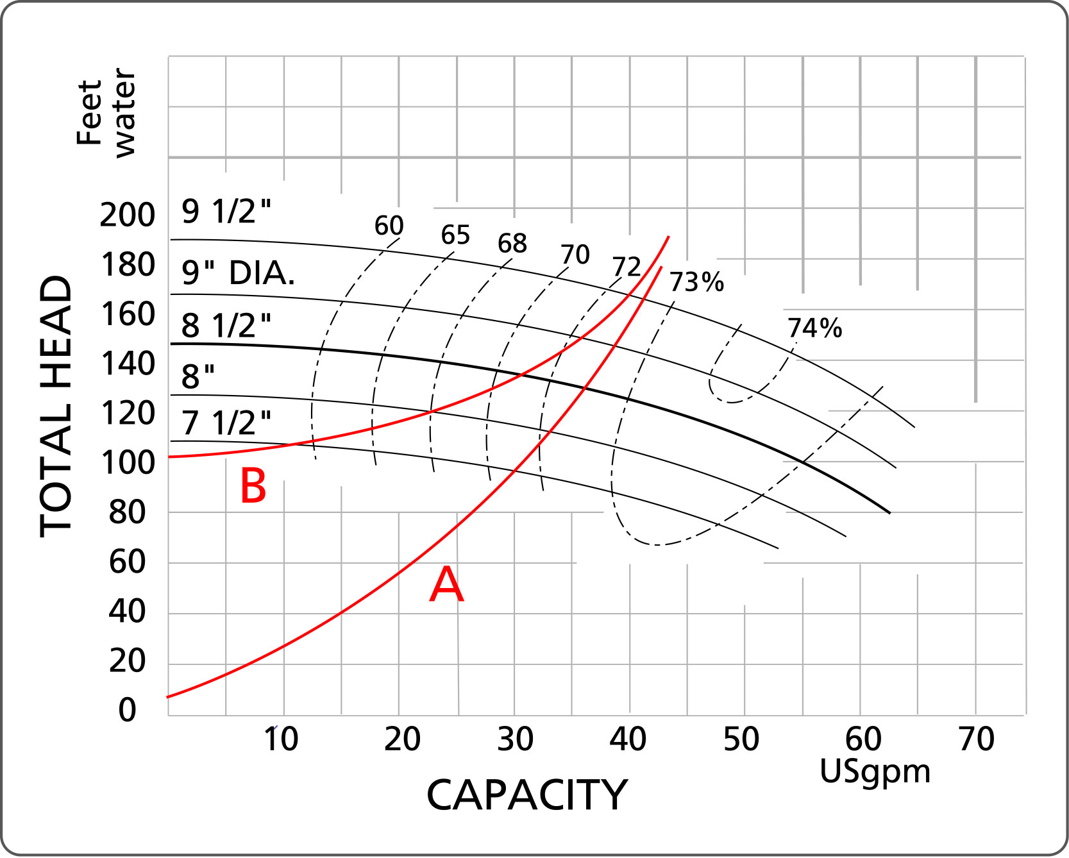
Figure 11 Limitation on the use of the affinity laws.

Symbols

Variable nomenclature | Imperial system  (FPS units) | Metric system  (SI units)
g acceleration due to gravity: 32.17 ft/s² | ft/s² (feet/second squared) | m/s² (meter/second squared)
N_{S} specific speed
S suction specific speed
H head | ft (feet) | m (meter)
N.P.S.H. Net Positive Suction Head
ΔH_{EQ} equipment head difference | ft (feet) | m (meter)
ΔH_{F} friction head difference | ft (feet) | m (meter)
p pressure | psi (pound per square inch) | kPa (kiloPascal)
SG specific gravity; ratio of the fluid density to the density of water at standard conditions | non-dimensional
Q flow rate | USgpm (US gallon per minute) | Cubic meters per hour
N impeller speed | rpm
v velocity | ft/s (feet/second) | m/s (meter/second)
z vertical position | ft (feet) | m (meter)

